T - 44 Systems Enabling Objectives

Chapter 1 - General Aircraft

1. State the type and manufacturer of the T-44C aircraft.
- Beech Aircraft / Beech Aircraft Corporation
2. State the mission of the T-44C aircraft.
- To train military aviators to fly multi-engine turboprop a/c
- To transport passengers/cargo
3. List the features of the T-44C aircraft.
- Deicing/anti-icing
- Instrumentation
- Navigational equipment
- Interior seats for: instructor, student, student observer, and up to two more passengers
- Student observer audio panel
- Non-flushing toilet
4. State the dimensions of the T-44C aircraft.
- Length: 35’6”
- Heighth: 14’ 2.6”
- Prop to ground: 11.5”
- Wingspan: 50’2.9”
- Prop Arc: 7’9”
5. State the maximum weight limitations for the T-44C aircraft.
- Max ramp: 9,710 lbs
- Max takeoff: 9,650 lbs
- Max landing: 9,168 lbs
6. State the airspeed limitations for the T-44C aircraft.
- VMO/VNE Max dive/level flight: 227
- VMCA Minimum controllable airspeed: 86
- VX Best AOC: 102
- VY Best ROC: 108
- VSSE Minimum safe 1 engine inop: 91
- VXSE Best AOC single engine: 102
- VYSE Best ROC single engine: 110
- VFE Max flap extension Full (100%): 140
- VFE Max flap extension Appr (35%): 174
- VLR Max landing gear retraction: 145
- VLE Max landing gear extension: 155
- VA Maneuvering speed: 153
- VMCG Min controllable speed on ground: 63
- Max range glide: 130
- Max endurance glide: 102
7. State the acceleration limitations for the T-44C aircraft.
- +3.0 to -1.0 g’s
8. State the altitude limitations for the T-44C aircraft.
- 31,000 feet
9. State the landing limitations for the T-44C aircraft.
- Flared Landings only
- Min sink rate at ground contact of 600 fpm
- Max crosswind component of 20 kts
10. State the maximum cabin pressure differential.
- 4.7 psi
11. List the prohibited maneuvers for the T-44C aircraft.
- Intentional spins
- Aerobatics
12. State the crew limitations for the T-44C aircraft.
- Min crew composition: pilot in command and co-pilot
- Min crew when carrying passengers is an a/c commander and either a second pilot, instructor under
- training, pilot under instruction, or an SNA
13. Describe the personnel equipment provided in the T-44C aircraft.
- The NATOPS lists seats and headsets
14. List and describe the rescue equipment aboard the T-44C aircraft.
- AV-8 life preserver
- Type II seven-man life raft
15. Describe the location and operation of the T-44C hand-held fire extinguishers.
- Two 2.5lb Halon 1211 hand-type fire extinguishers, 1 located below co-pilot’s seat and another stored on the left-hand seat riser just forward of the airstair door
16. Describe the location and removal procedure for the T-44C first-aid kit.
- A first-aid kit is stored on the forward side of the stub partition in the aft cabin. It’s removed by pulling the red hinge pin
17. Describe the location and operation of the T-44C emergency locator transmitter.
- The ELT in AFC 20 aircraft is located in the lower right rear section of the fuselage, aft of the pressure bulkhead
- The ELT is designed to transmit a beeping tone on the emergency frequencies, 121.5 (VHF) and 243.0 (UHF), whenever the aircraft contacts the ground with a preset force
- Self-contained battery ensures continuous transmitting for 48 hours
- Instrument panel mounted and mounted switch, communicating with the COPAS / SARSAT satellite system and the aircraft’s GPS
18. Describe how to check that the main cabin door is properly locked.
- When the door is locked, two micro switches are closed and the red CABIN DOOR OPEN light on the annunciator panel in the cockpit is extinguished
19. Describe the location and operation of the emergency exit.
- Located at the third cabin window on the right side of the fuselage.
- Adjacent to the hatch is a striped access door. Inside the door is a flush-mounted handle that can be pulled to open the hatch.
- Instructions for opening the hatch are placarded on the access door.

Chapter 2 - Electrical System

1. Describe the function and characteristics of the four (4) DC power supplies.
- 24-volt, 42 amp hour lead acid battery
  - Mounted in right wing root. Controlled by switch on control pedestal. Can supply power to all DC powered equipment
  - Functions: 1. Provide emergency power. 2. Provide power to start engines. 3. Act as a damper by absorbing power surges
- 250 ampere starter-generator (left)
  - Provides 28 Vdc and has a rated output of 250 amps
- 250 ampere starter-generator (right)
  - Provides 28 Vdc and has a rated output of 250 amps
- 24-volt, 5 amp hour auxiliary battery
  - Located in the avionics bay
  - Capable of powering the Avionics Essential Bus for 30 minutes with a loss of both generators and the main battery
2. Label and describe the functions of DC gauges.
- ref figure 2-1. Measures the load of each generator, L/R fuel quantities, and the main battery voltage
3. Label and describe the function of the DC busses and their components.
- Receives power from the generator and distribute the power to a/c DC loads
4. Describe the function of the inverters.
- Convert DC power to AC power
5. Label and describe the functions of the AC gauges.
- N/A
6. Label and describe the function of the AC system.
- N/A
7. Label and describe the function of the annunciator panel and its components.
- Mounted across the top of the instrument panel and provides a visual monitor for all the critical functions of the aircraft and indicates conditions for which corrective action must be taken
8. Label and describe the function of the interior lighting controls.
- All aircraft interior lighting is controlled by either rheostat or press-to-light switches located on the overhead control panel
- A push-on-off MASTER COCKPIT LIGHTS switch is located in the overhead control panel. This switch exercises ON or OFF control for all circuits controlled from the overhead except indirect instrument lights and the two cockpit utility lights. It is in series with the individual lighting control switches and must be ON to enable the individual switches to function
9. Label and describe the function of the exterior lighting controls (Fig 2-11).
- Navigation and strobe lights on the tail section and on each wingtip
- Anticollision lights (rotating beacon) on the vertical stabilizer and the underside of the fuselage center section
- Single taxi light and dual landing lights mounted on the nose landing gear strut
- Two ice lights, one light flush mounted in each nacelle, positioned to illuminate along the outboard wing leading edge
- In the event the landing and taxi lights are inadvertently left on, they will automatically be switched off when the landing gear is retracted. This automatic function is intended as a backup system to prevent heat damage

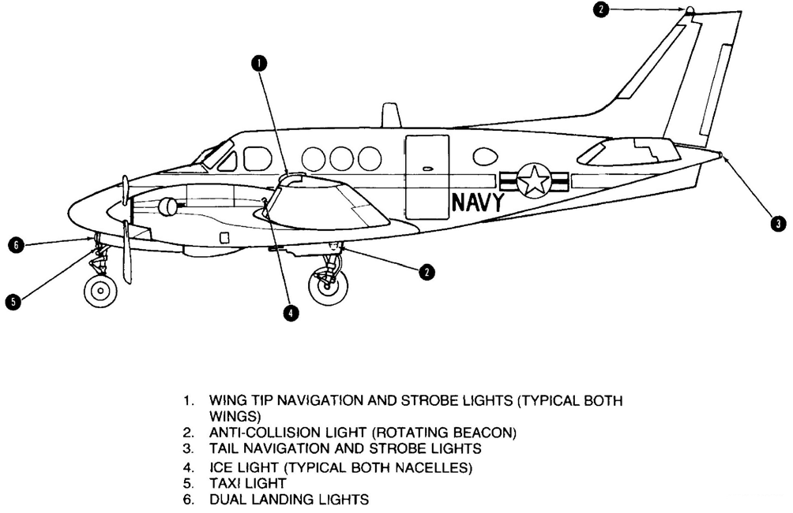
10. Recognize the indications and potential results of a generator malfunction.
- First indication: illumination of a LH GEN OUT or RH GEN OUT with a flashing FAULT WARN
11. State the emergency procedure to be used during a single or dual-generator failure.
- Turn the generator off and attempt a reset. If unsuccessful, generator check and current limiter (Generator Failure EP)
- With dual gen loss, A/C operates on main battery power for 42 amp hours, could be as few as 10 mins.
12. Recognize the indications and potentials results of a current limiter failure.
- Failed if LH or RH fuel quantity gauge on fuel management panel indicates zero, with both generators off and battery on
- Indicated by a loadmeter split of 0.1 or greater with the higher load on the left main bus assuming air cond/heat is functioning
- Results: The main battery is not being charged and the battery voltmeter will read 24V (the battery voltmeter reads 28V when the battery is charging)
13. Recognize the indications and potential results of an inverter malfunction.
- N/A
14. State which circuit breakers are essential and may be reset and which circuit breakers must never be reset.
- Essential circuit breakers may be rest only ONCE.
- NEVER reset: 1. Subpanel Feeder Circuit Breakers (labeled Feeder Bus Circuit Breakers in the aircraft) 2. Non-essential Circuit Breakers

Chapter 3 - Power & Related Systems

1. State the PT6A-34B engine characteristics.
- Each engine is rated at 550 shp. Each are a reverse flow, free turbine type engine, employing a three stage axial and a single stage centrifugal compressor.
2. Label and describe the function of the reduction gear box and its components.
- Located forward of the turbine section and is directly connected to the power turbine. It is comprised of a two stage planetary reduction gearbox system connected to the propeller
- Provides a 15:1 reduction ratio from the power turbine to the propeller
3. State any limitations for the reduction gear box and its components.
- Provides a 15:1 reduction ratio from the power turbine to the propeller
- When the power turbine is turning at 33,000 rpm, the reduction gear box reduces this to a propeller speed of 2200 rpm, equaling 1,315 ft-lbs of torque
- When the power turbine is turning at 28,500 rpm, the reduction gearbox reduces this to a propeller speed of 1900 rpm, equaling 1,520 ft-lbs of torque
4. Label and describe the function of the combustion chamber and its components.
- Located forward of the compressor section
- High pressure air is mixed with fuel to form a combustible gas. Approximately 25% of the intake air is mixed with fuel and burned
- It is comprised of a circular chamber with 14 fuel nozzles (10 primary and 4 secondary) and 2 igniter plugs
5. Label and describe the function of the compressor and its components.
- Comprised of a 3-stage axial compressor and a single stage centrifugal compressor. The compression ratio is 7:1
- N1, or gas generator, compresses the air and drives the accessories section
- When the N1 gauge reads 100%, the gas generator/compressor speed is 37,500 rpm
- When the N1 gauge reads 101.5%, the gas generator/compressor speed is 38,000 rpm
- 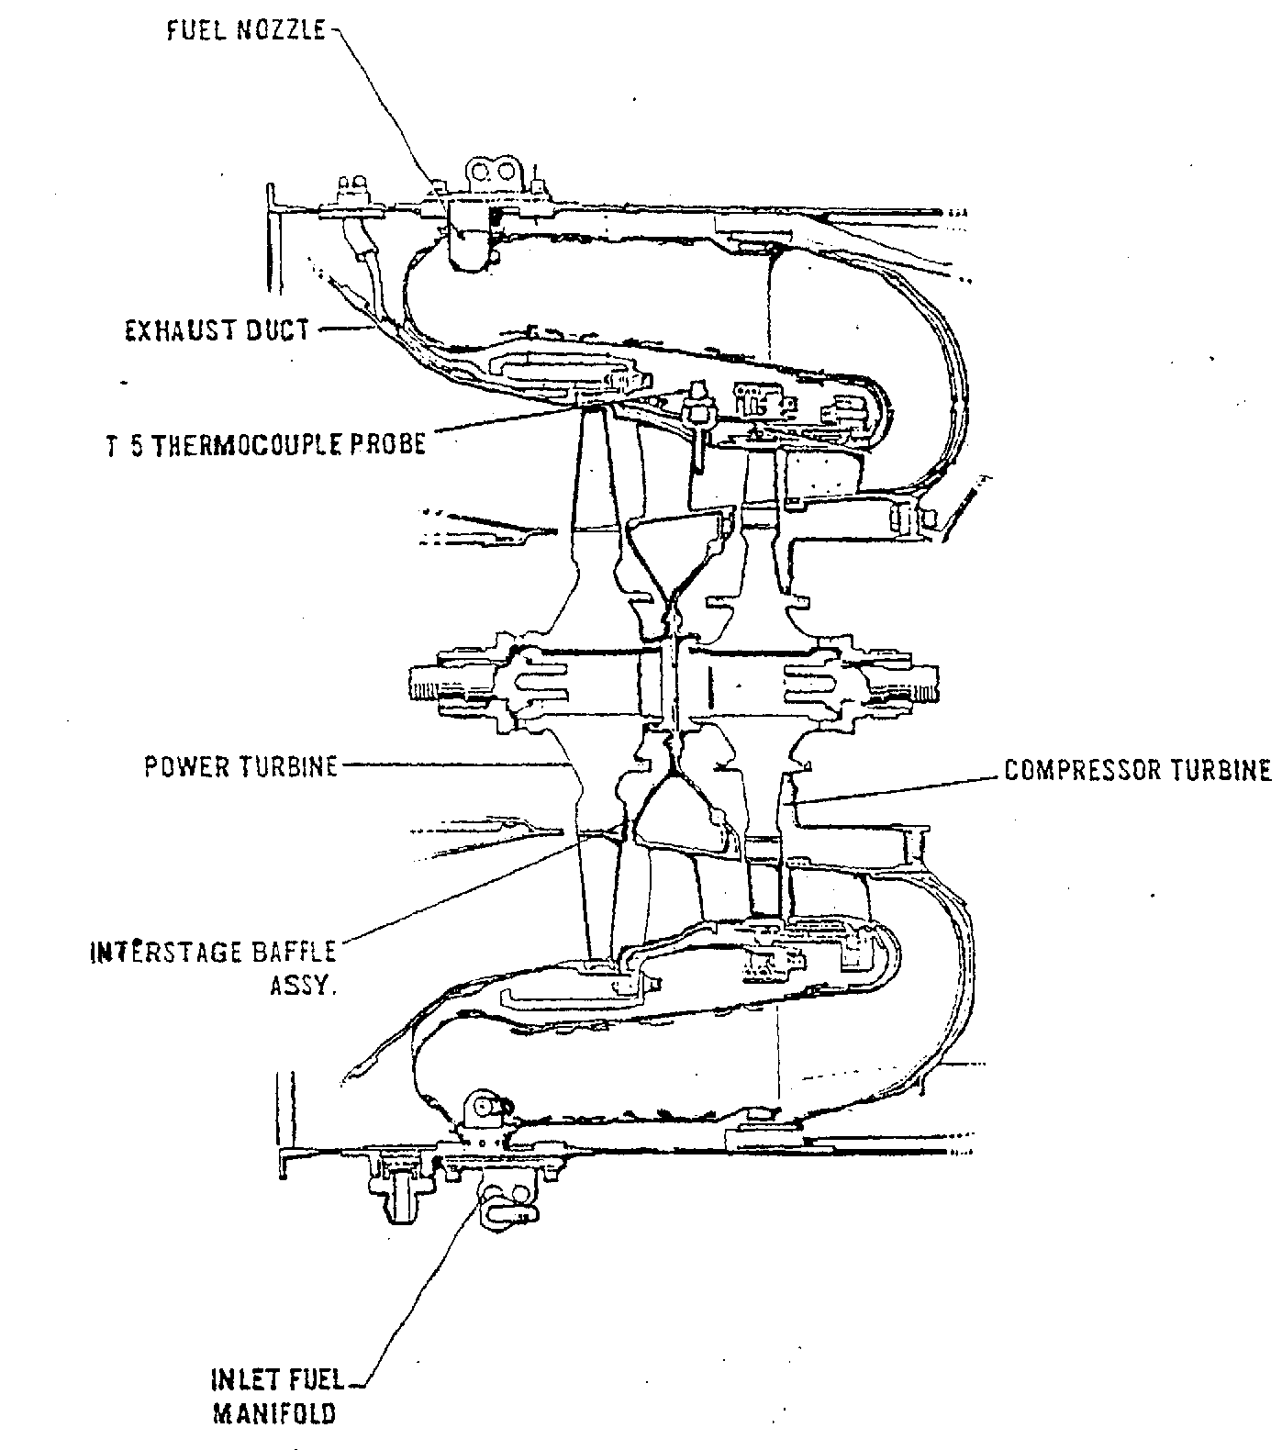
6. Label the fuel control system.
- Consists of an engine-driven pump, a fuel control unit, start control unit, a common manifold, and 14 fuel spray nozzles
- The engine-driven fuel pump is mounted on the accessory section of the engine. This pump operates anytime the compressor is turning. This pump is required for engine operation and a failure results in a flameout
7. Label and describe the function of the fuel drain collector system and its components.
- Located in the accessories section and is composed of a tank and a pump
- When the tank is full, the fuel collector tank collects residual fuel from the flow divider. The tank is located below the engine accessory section
- A drain valve bleeds off any residual fuel to the fuel drain collector tank after engine shutdown or a discontinued start
- The fuel drain collector pump automatically transfers residual fuel back to the nacelle tank. The fuel drain collector pump is powered by the No. 1 or No. 2 Subpanel Feeder Buses
8. Label and describe the functions of the engine instruments.
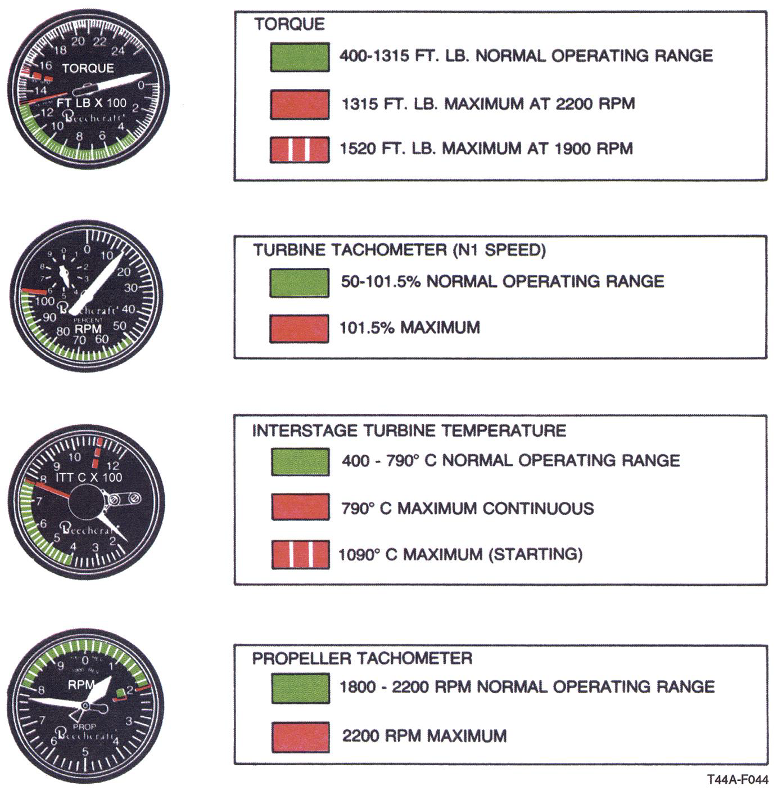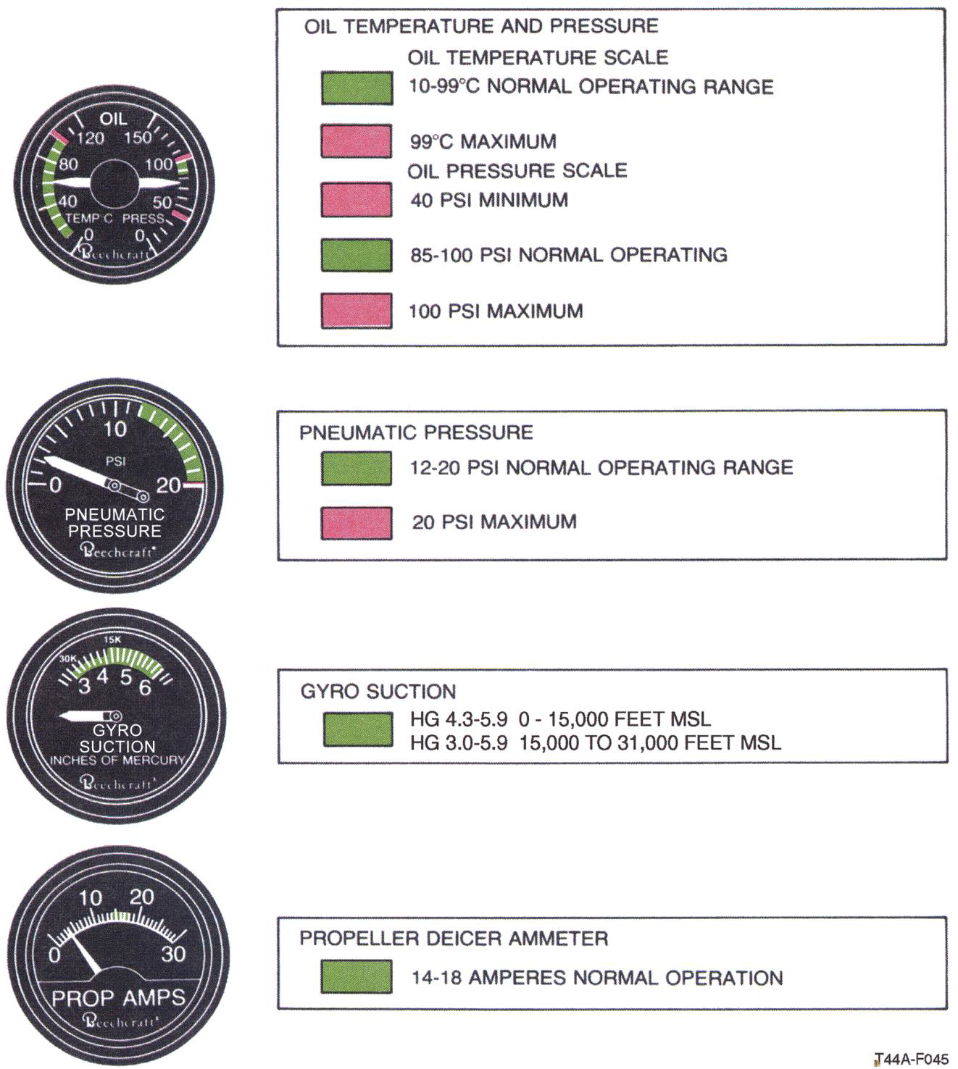
9. Label and describe the function of the starter system and its components.
- Upon startup and once in the combustion chamber, the air is mixed with fuel and ignited by igniter plugs that operate during engine start or during autoignition. After start, combustion continues as long as the fuel-to-air ratio is correct
- The start control unit is a mechanical fuel control valve operated by the condition levers. As the levers move out of the FUEL CUTOFF position, the valve opens allowing fuel to enter the primary fuel manifold. When the levers are in the FUEL CUTOFF position, the valve closes cutting off fuel to the fuel manifold. A diagonal rod from this unit to the FCU allows for idle RPM adjustment using the condition levers
10. Label and describe the function of the autoignition system and its components.
- If “armed,” the autoignition system automatically provides combustion reignition of either engine should accidental flameout occur
- The system is not essential to normal engine operation, but is used to reduce the possibility of power loss because of icing or other conditions
- Each engine has a separate autoignition control switch and a green indicator on the annunciator panel Autoignition is accomplished by energizing the two igniters in each engine anytime the autoignition system is armed and the engine is operating below 410 ±50 ft/lb torque
11. State any limitations for the engine starter system and its components
- The starters are limited to an operating period of 40 seconds on, 60 seconds off for two cycles; then 40 seconds on, 30 minutes off on the third
12. Label and describe the operation of the power levers.
- Regulate developed power from idle to maximum and operate so that forward movement increases N1. Power is controlled by adjusting the N1 speed governor in the fuel control unit
- The power lever is connected to the cam box which is connected to the fuel control unit and the beta linkage
- The power levers also control reverse propeller pitch and engine power. Distinct movement (pulling up and then aft on the power lever) is required to obtain beta or reverse thrust. Power lever movement in the beta range (area from IDLE to REVERSE, 15 to -5° blade angle) controls propeller pitch only. In the REVERSE range (-5 to -11° blade angle), power lever movement controls both N1 rpm and propeller pitch
- WARNING: Mechanical stops incorporated in the throttle quadrant prevent rapid forward movement of the power levers from the beta range to the flight range. Downward pressure must be applied to the power levers to permit movement into the flight range and allow power to be added.
- CAUTION: Moving the power levers aft of IDLE without the engines running will result in damage to the reverse linkage mechanisms.
- 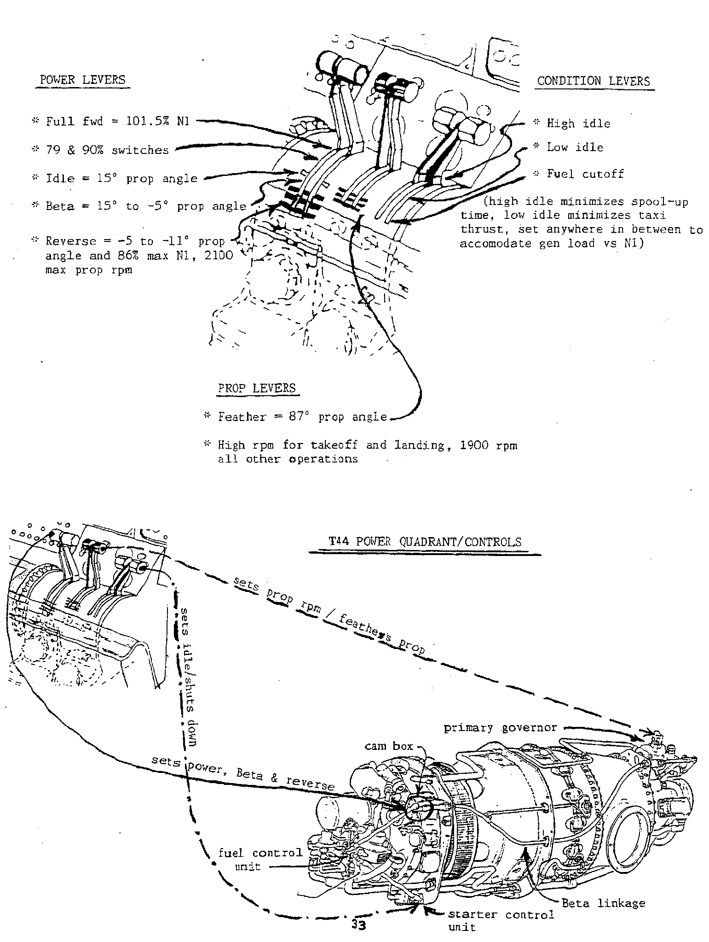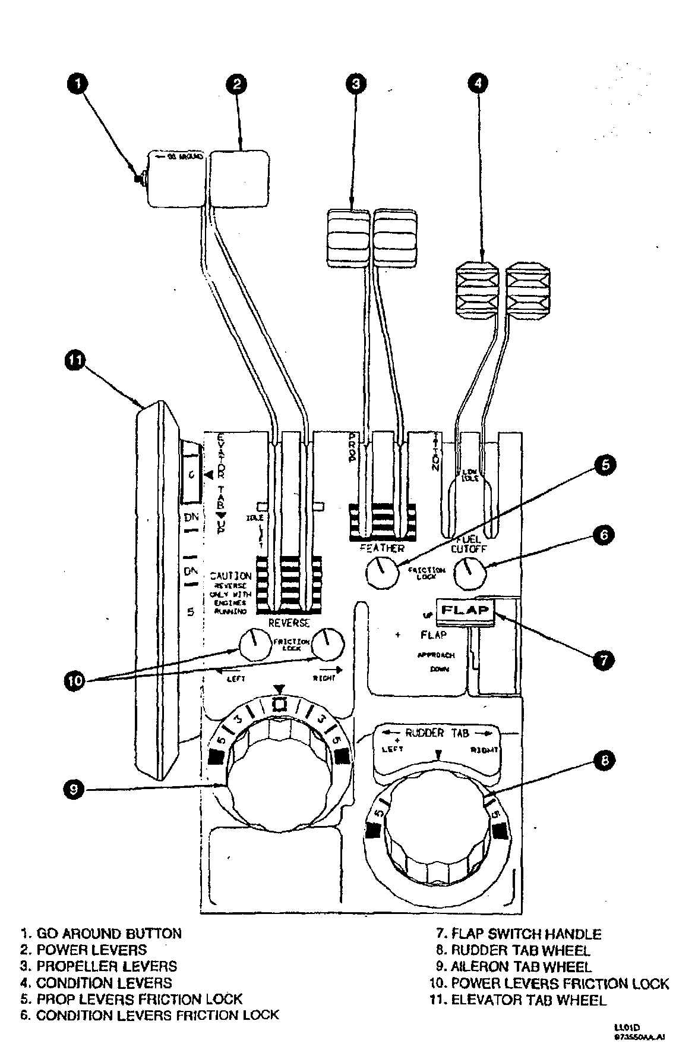
13. Label and describe the operation of the condition levers.
- Used to start or stop fuel supply to a corresponding engine and control engine idle speeds. Placed in the FUEL CUTOFF position, the start control unit is closed and fuel flow to the corresponding engine is terminated. Forward movement of the levers from the FUEL CUTOFF position will set the fuel control units to provide a minimum of 51-percent N1 in the LOW IDLE position (normally 51 to 54 percent) and a minimum of 70 percent in the HI IDLE position (normally 70 to 73 percent)
- At a PA less than 3,500 feet, fuel flow is metered to maintain idle speed at a constant value. Because the fuel flow required to maintain a constant idle speed decreases with increasing altitude, a minimum fuel flow setting on the engine fuel control unit is reached during ground operations above a PA of 3,500 feet and may produce idle speeds as high as 83-percent N1
14. Label and describe the function of the oil system and its components.
- The engine oil supply is contained in an integral oil tank located between the engine air inlet area and the accessory case. Engine oil cools and lubricates the engine, operates the propeller pitch change mechanism and engine torquemeter system. The system capacity per engine that includes the oil tank, lines, and oil cooler is 14 quarts
- The oil-to-fuel heater is located on the top of the accessory section and uses heat from engine oil to preheat the engine fuel
- A fuel temperature sensing bypass valve allows oil to flow into the heater core when the fuel temperature is low. When fuel temperature increases to 70° F the valve begins to close and restricts the amount of oil entering the core. At 90° F the valve closes completely and the oil bypasses the heater core
- 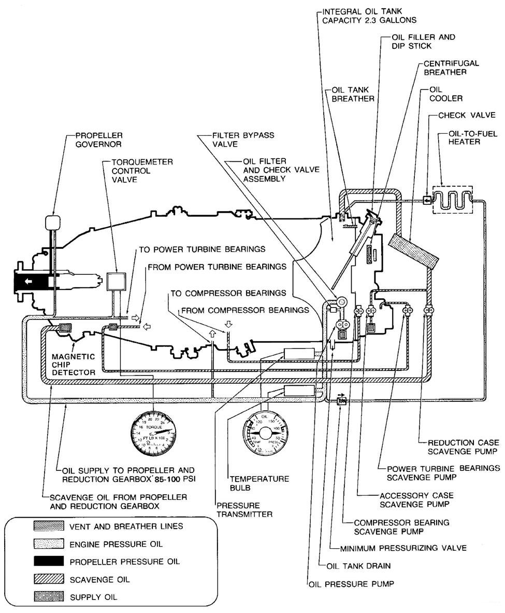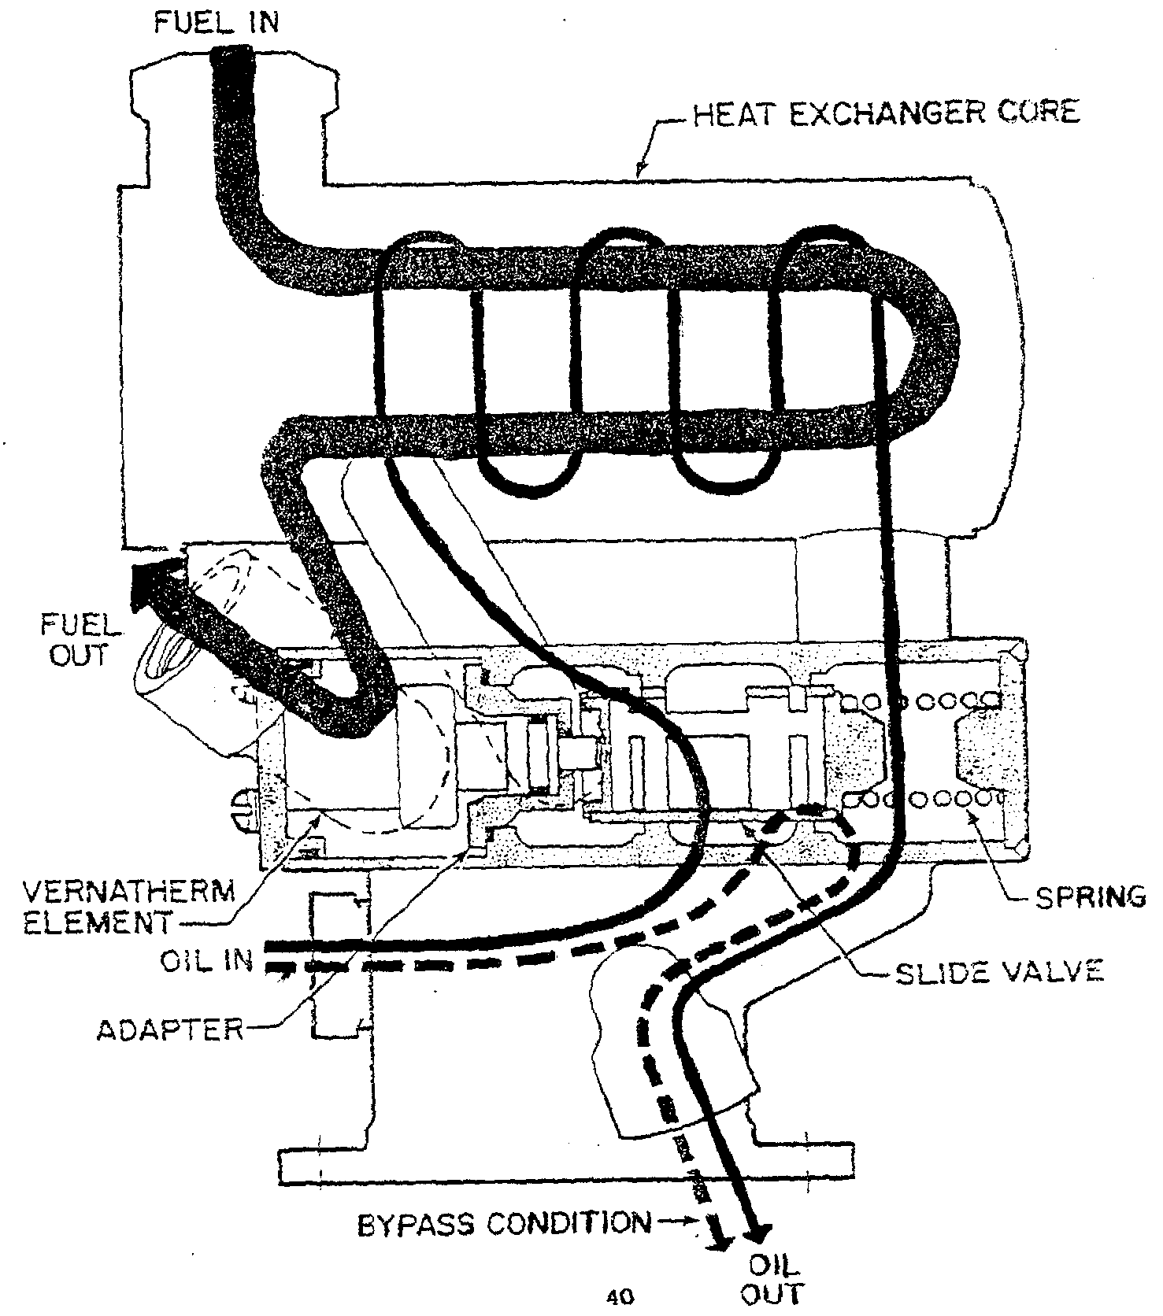
15. Label and describe the operation of the components of the fire detection and extinguishing system.
- Fire Detection: A flame surveillance system is installed on each engine to detect external engine fire and illuminate the fire warning lights. Both nacelles are monitored, each having a control amplifier and three detectors. In each nacelle, one detector monitors the forward nacelle and both exhaust outlets; a second monitors an upper accessory area and a third the lower accessory area. The system includes a functional test switch and circuit protection is through the FIRE DETR circuit breaker. Dc power is derived from the No. 2 subpanel bus. Radiation exposure from a fire activates the relay circuit of the control amplifier that causes signal power to be sent to cockpit indicators. An activated surveillance system will return to the standby state after the fire is out.
- Warning of internal nacelle fire: The FAULT WARNING light flashes and accompanied by the red LH FIRE or RH FIRE light and fire extinguisher switch.
- 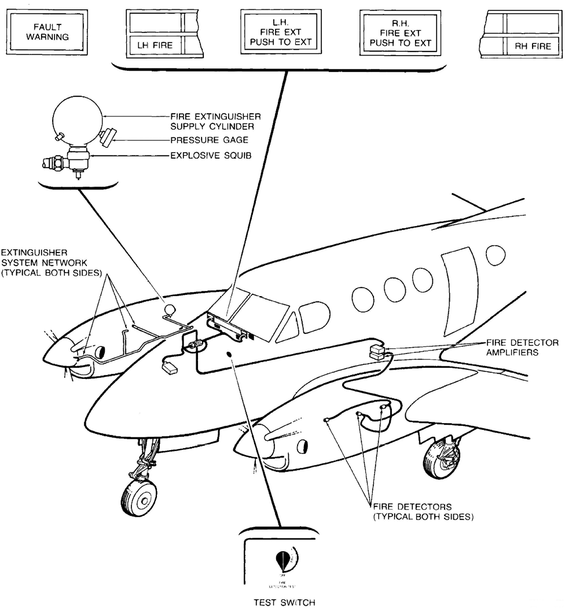
- Extinguishing system: utilizes an explosive squib which, when activated, allows the distribution of the pressurized extinguishing agent through a plumbing network of spray nozzles strategically located in the fire zones of the engines. A gauge calibrated in pounds per square inch (psi) is mounted on each supply cylinder located on the aft side of the main spar in each wheelwell for determining the level of charge and should be checked during each preflight.
- CAUTION: Receives DC power from hot battery bus. A battery connection is the only requirement for the extinguisher to be armed. Pressing either left or right FIRE EXT PUSH TO EXT button will fire the squib and discharge the respective fire bottle

Chapter 4 - Propeller System

1. Label the components of the propeller system.
- 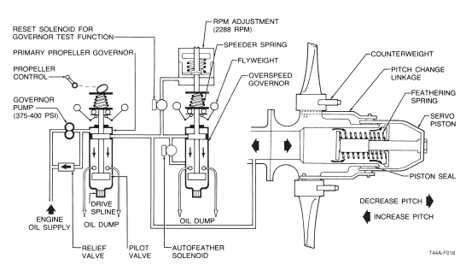
2. Label and describe the function of the propeller control system and its components.
- Each prop lever sets the rpm for its respective propeller by adjusting the speeder spring tension on top of the primary governor. The prop system is hydraulically controlled, constant speed, full-feathering, and reversible. Engine oil provides the hydraulic control in the propeller system. It is driven through the primary governor by the governor pump
- The primary governor controls the prop rpm for the entire normal range of rpm by sensing the flyweight rotation against the speeder spring and metering oil through the pilot valve
- If a primary governor malfunctions and the prop exceeds 2200 rpm by more than 4%, the overspeed governor limits high pressure oil to maintain propeller speed at 2288 rpm +/- 40
- A pneumatic section of the primary governor acts as a fuel topping governor if the overspeed governor fails and propeller speed exceeds 2332 rpm
- Attached to the overspeed governor is the autofeather solenoid which automatically dumps oil to feather the propeller in the event of a severe power loss
- The propellers consist of three aluminum blades with over-center bladeshank counterweights
- The feathering spring and bladeshank counterweights will normally feather the propeller any time there is loss of boosted propeller governor oil pressure
3. State the three (3) RPM limitations on the propeller governors.
- Normal operating range: 1800-2200 rpm
- Max reverse: 2100 rpm
- Max during acceleration (2 sec): 2420 rpm
4. Recognize the indications and potential results of a propeller governor failure.
- Primary governor failure can be detected by propeller N2 speeds of 2288 +/- 40 (overspeed), or uncommanded propeller feather. If a propeller should stick or move too slowly during a transient condition, the corresponding governor would be unable to prevent an overspeed condition. To provide for this contingency, the pneumatic section of the primary governor acts as a fuel topping governor when the propeller rpm exceeds 2,332 rpm (2,200 rpm + 6 percent). This limits the fuel flow into the engine, thereby reducing the power driving the propeller. During propeller operation in the reverse range, the pneumatic section of the primary governor will be reset to allow a maximum of 2,100 rpm
5. Recognize the indications and potential results of a propeller linkage failure.
- Moving the power levers aft of IDLE without the engine running will result in damage to the reverse linkage mechanism. To prevent damage to reversing linkage, propeller levers must be in HIGH RPM position prior to propeller reversing
- If the propeller governor control linkage fails, the affected propeller will remain at its current setting or increase to 2200 rpm
- You will manipulate the propeller lever to attempt to regain normal operation. If unable, you will match the opposite propeller rpm with the uncontrollable one and land as soon as practical
6. Label and describe the function of the overspeed governor and related controls.
- In the event of primary governor malfunction, the overspeed governor cuts in and dumps oil from the propeller dome to prevent rpm from exceeding safe limits
7. Label and describe the function of the autofeather system and its components.
- The autofeather system provides rapid prop feathering in the event of an engine power loss on takeoff or wave off.
- If an engine loses power, with the system armed and the power levers at or above a position corresponding to 90% (+/-2) N1, two torque-sensing switches are actuated resulting in the affected engine’s propeller feathering
- NOTE: With the autofeather switch in the ARMED position, retarding one or both power levers below the 90% position will completely disengage the autofeather system
- When the affected engine drops below 410 (+/- 50) ft-lbs. torque, the first torque sensing switch turns off the autofeather system for the opposite engine and deenergizes the opposite engine’s autofeather light
- When the affected engine drops below 260 (+/- 50) ft-lbs. torque, the second torque sensing switch causes the autofeather system to activate, completing the circuit to the solenoid
- Autofeather is normally used in the terminal area, on low levels, and as an alternate means to feather the prop in an emergency
- Autofeathering is controlled by a propeller AUTOFEATHER switch on the pilot subpanel. This switch is a three position switch placarded ARM, OFF, and TEST. The TEST position allows the 90% N1 power lever micro-switch to be bypassed to facilitate ground testing of the autofeather system.
8. Label and describe the function of the synchrophaser system and its components.
- The system reduces the interior noise level and minimizes stress on the fuselage.
- The Synchrophaser System provides two functions:
  - 1. To synchronize the propellers to the same prop rpm read on the gauge, lowering the ambient noise level in the cabin.
  - 2. To phase the blades so that no two blades pass the fuselage at the same time, which reduces airframe stress.
- The left propeller is the master and the right propeller is the slave. Both props have a magnetic speed pickup mounted in their overspeed governor and three magnetic phase pickups mounted on their de-ice slip ring which transmits electronic pulses to a control unit.
- The control unit converts any pulse rate differences into correction commands and these correction commands are then transmitted to an actuator motor mounted on the right engine.
- The actuator motor then trims the right propeller governor assembly to match the left propeller rpm while leaving the left propeller control lever position constant. When the prop sync switch is OFF, the synchrophaser actuator will recenter and may take 6 secs.
- The synchrophaser is limited to +/- 30 rpm from the normal governor setting to prevent the slave propeller from losing excessive rpm if the master propeller is feathered while the synchrophaser system is on.
- The right propeller may not fully feather with the propeller sync switch on.
- 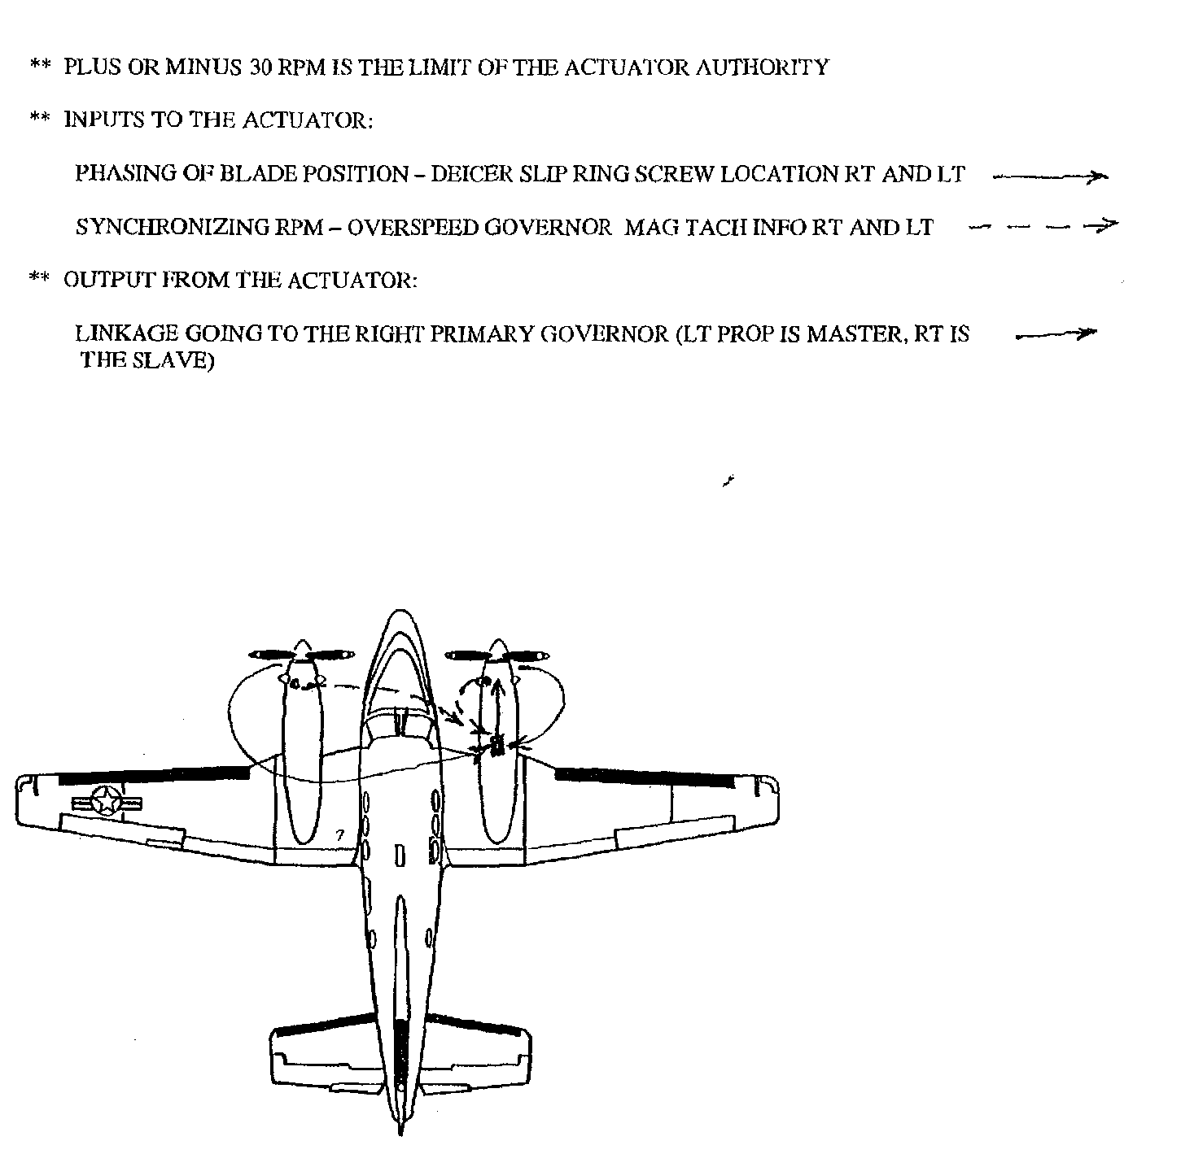
Chapter 5 - Fuel Systems

1. Label the components of the fuel system.
- 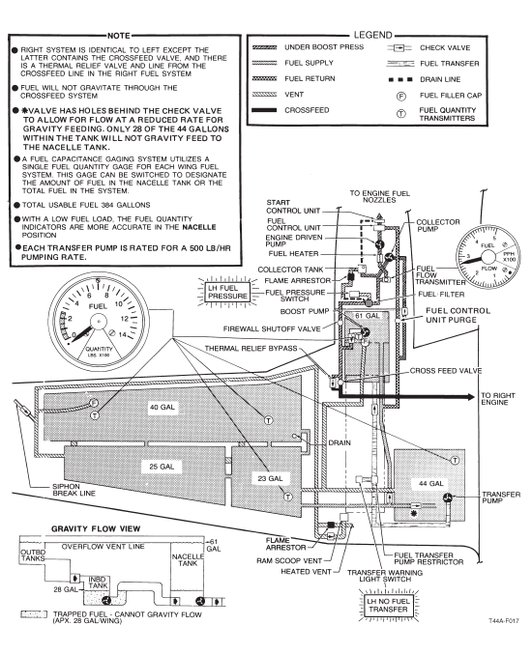
- 1. The fuel capacity of the wing tanks is 132 gallons.
- 2. The fuel capacity of the nacelle tanks is 61 gallons.
- 3. The total fuel capacity is 387.6 gallons of which 384 gallons are usable.
2. List the (5) approved fuels for the T-44C aircraft.
- 1. Jet A1, Jet B, Jet 4, JP-5, JP-8 (Jet A and F42 are alternate fuels)
- AVGAS grades 80/87/100LL through 115/145 may also be used (Emergency Use Only), limited to 150 hours between overhaul
- CAUTION: JP-8 +100 shall never be used in the T-44C as it can clog the fuel filter
3. Describe the functions of all system components that assist fuel flow from the tanks into the engine.
- Fuel is gravity fed into the fuel tanks through four fuel filler caps: one on each wing and one on each nacelle
- Fuel is gravity fed from outboard tanks to the center section (inboard) tank
- The fuel transfer pump is located in the center section tank and pumps fuel from the inboard wing tank to the nacelle tank at a rate of 1 1/4 GPM or 500 PPH (approx. 75 GPH)
  - The transfer pump can be electronically controlled from the fuel management panel to run continuously (OVERRIDE position), or it can be automatically controlled (AUTO position) by float switches in the nacelle tank
  - In the AUTOMATIC mode, each transfer pump is controlled by three float switches: upper-level, middle-level, and lower-level
  - 1. The lower-level switch is set at approximately 42 gallons (turns pump on)
  - 2. The middle-level switch is set at approximately 51 gallons (turns pump off)
  - 3. The upper-level switch is set at approximately 59 gallons (turns pump off if the 51 gallon switch fails)
  - Normally, the fuel in the nacelle tank will drop to 42 gallons as the engine consumes fuel. Then the transfer pump will activate to fill the nacelle tank to the 51-gallon level at which point it cuts off. This cycle continues until the fuel in the center section tank is depleted
  - The float switch operation is automatic and requires no action by the pilot
  - If fuel transfer fails with fuel still in the wing tanks, fuel will flow by gravity from the inboard wing tank into the nacelle tank when the nacelle tank drops to 3/8 full (about 160 pounds of JP-5). However, the last 28 gallons will be trapped in the inboard wing tank (cannot gravity feed)
  - In the OVERRIDE mode, the transfer pump is continuously energized. The float switches in the nacelle tank are bypassed and the 3 psi pressure switch is reset
- The fuel boost pumps are located in the left and right nacelle tanks. They provide approximately 30 psi head pressure fuel to the engine-driven high pressure pump inlet and provide fuel pressure for crossfeeding during continued single engine operations
  - They are dual powered by their respective fuel busses and the hot battery bus
4. Recognize the indications and potential results of a transfer pump malfunction.
- If the RH/LH NO FUEL TRANSFER light illuminates (transfer pump switch in auto): Check total fuel and nacelle fuel quantities
  - 1. If total fuel quantity equals nacelle fuel quantity, then no fuel remains in the wing tanks to transfer. Turn transfer pump off
  - 2. If total fuel quantity is greater than nacelle fuel quantity, then determine if the 28 gallons of trapped fuel are necessary
    - a. If the 28 gallons are necessary then position transfer pump switch to override
      - i. If the NO FUEL TRANSFER annunciator extinguishes, the pump is operable and pump operation may continue in override mode
      - ii. If the NO FUEL TRANSFER annunciator does not extinguish, the pump has failed. Turn transfer switch to off. A maximum of 28 gallons of fuel will be unusable in the respective wing tank
    - b. If the 28 gallons are not necessary, do not use override and turn the pump off. Gravity flow will begin once the nacelle drops to 3/8 full
- In both cases, land as soon as practicable
  - 3. If there is fuel in the wings but the nacelle quantity is in the yellow arc, and there is no associated annunciator light, the one of the following may have occurred
    - a. Transfer pump switch could be in the off position
    - b. Transfer pump circuit breaker is out. Pump operation and annunciator light operation will be inhibited.
    - c. 42 gal float switch is inoperative. Select override and monitor fuel quantity
- NOTES: 1. When the transfer pump switch is in the AUTO position, power will automatically be removed from the pump when the NO FUEL TRANSFER light illuminates. 2. Unlike boost pump warnings, transfer pump warning circuit logic involves not just a simple pressure switch; otherwise, the pilot would be warned every time the float switch turns off the pump automatically. The warning occurs if the pressure switch detects < 3 psi for 30 seconds and the pump is told to run
5. Recognize the indications and potential results of a boost pump malfunction.
- When a boost pump fails, the respective FUEL PRESSURE light flickers and the CROSSFEED annunciator remains illuminated because the crossfeed valve will open automatically (if in AUTO position). The crew must then close the crossfeed valve to determine which boost pump has failed. Then a decision must be made to crossfeed or to suction lift the fuel. Crossfeed operation is used if range is not a factor. Suction lift is used if range is critical
- NOTE: For descent for landing, crossfeed should be selected to guarantee boosted pressure in case of waveoff
- CAUTION: Engine-Driven fuel pump operation without boost pump fuel pressure (suction lift) is limited to 10 hours
6. State two limitations for using suction lift.
- CAUTION: Engine-Driven fuel pump operation without boost pump fuel pressure (suction lift) is limited to 10 hours
- NOTE: If range because of crossfeed operation is critical, suction lift may be utilized at all cruise altitudes but should be discontinued in favor of crossfeed (boosted pressure) when initiating descent for landing in the event of a missed approach
7. Label and describe the operation of the crossfeed system and its components.
- 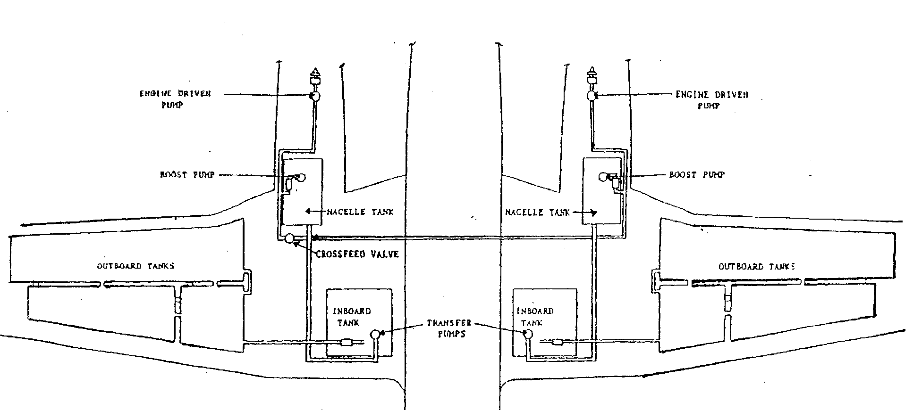
- The crossfeed system is used to crossfeed fuel from fuel tanks on one side of the aircraft to the engine on the opposite side of the aircraft. The crossfeed system cannot be used to transfer fuel from one nacelle to the other nacelle. Generally used when a boost pump or an engine fails
- The crossfeed valve is dual powered. It normally receives electrical power from the No. 1 fuel bus; however, the crossfeed valve is also connected to the hot battery bus
- Normally, in the AUTO position the crossfeed valve is automatically controlled by a pressure sensor in the fuel supply line; however, the crossfeed valve can also be manually opened or closed by a switch on the fuel management panel (OPEN, CLOSED)
- Under normal flight the valve is closed and the switch is left in AUTO position. With the crossfeed switch in the AUTO position, the crossfeed control circuitry is connected to the boost pump pressure sensing switches. If these sensing switches detect a pressure drop from a nominal 30 psi to below 5 psi, the system automatically opens the crossfeed valve
  - Do not fly with the crossfeed valve open under normal conditions as the strongest boost pump will feed both engines and an imbalance will occur
  - Loss of a boost pump and an engine on the same side will result in the fuel on that side being unusable

- The purge valve opens to purge air and excess fuel any time the starter switch is placed in the IGNITION and START position
- There are 5 fuel drains on each wing (four sump drains and one filter drain)

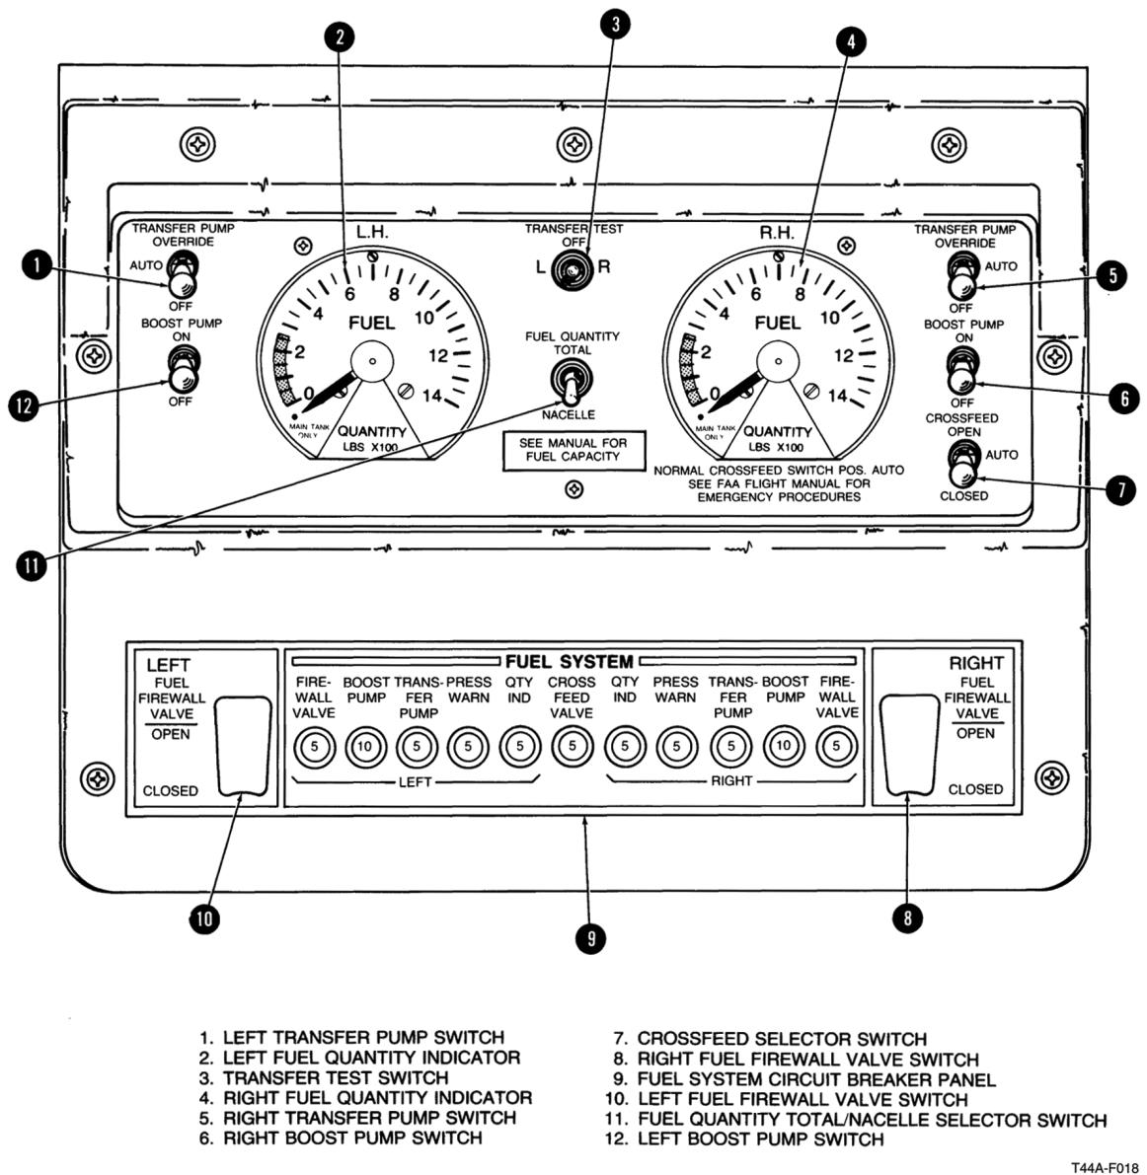

Chapter 6 - Flight Controls

1. Label and describe the operation of the primary flight controls.
- 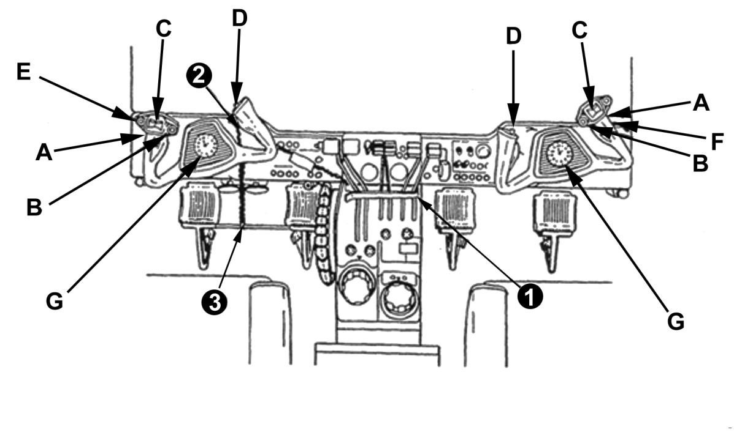
- 1. ENGINE CONTROL LOCK
- 2. AILERON ELEVATOR LOCK PIN
- 3. RUDDER LOCK PIN

- PILOTS CONTROL WHEEL
- A. MICROPHONE SWITCH
- B. AP/YD TRIM DISCONNECT SWITCH
- C. ELEVATOR TRIM SPLIT THUMB SWITCH
- D. MAP LIGHT SWITCH
- E. PITCH SYNC/CWS SWITCH
- G. EIGHT DAY CLOCK
- CO-PILOTS CONTROL WHEEL
- A. MICROPHONE SWITCH
- B. AP/YD TRIM DISCONNECT SWITCH
- C. ELEVATOR TRIM SPLIT THUMB SWITCH
- D. MAP LIGHT SWITCH
- F. GO AROUND SWITCH
- G. EIGHT DAY CLOCK

2. State the items incorporated on the control wheel.
- See above figure
3. Describe the rudder pedal functions.
- The aircraft rudders and nosewheel steering are controlled with the pilot or copilot rudder pedals
4. Describe the operation of the nose wheel steering system.
- Direct linkage from the rudder pedals to the nose wheel steering linkage allows the nose wheel to be turned 12° left of center and 14° right
- When rudder pedal action is augmented by main wheel braking, the nose wheel can be deflected up to 48° either side of center.
- Retraction of the landing gear automatically centers the nose wheel and disengages the steering linkage
5. State the function of the elevator trim system.
- The purpose of the trim tabs is to minimize control forces. Elevator trim helps control rotational forces about the pitch axis
6. Describe the operation of the manual elevator trim tab.
- The manual elevator trim wheel controls the trim tab for each elevator. The elevator trim tab control wheel is placarded ELEVATOR TAB UP or DOWN
- A position arrow on the control wheel indicates the amount of elevator tab deflection in degrees from neutral
7. Describe the operation of the electric elevator trim system.
- Normally, the pilot or copilot controls elevator trim with the electric elevator trim switches and a trim disconnect switch on the pilot and copilot control wheels; however, elevator trim can also be controlled manually using the elevator trim wheel. The electric elevator trim motor is powered via the PITCH TRIM circuit breaker on the copilot right outboard subpanel
- The elevator trim tab is a little different from other trim tabs. It incorporates an anti-servo action. That is, as the elevator is displaced from the neutral position, the trim tab moves in the same direction as the applied control surface. This increases the effective control surface area and the manual force required to further deflect the elevator
- The electric elevator trim switches are dual element, thumb switches and the left seat electric elevator trim switch takes priority over the right seat should both be simultaneously activated
8. Describe the operation of the aileron trim tab system.
- Full travel of the aileron trim tab (six units) is equal to 15 degrees of up and down movement. Once adjusted to a new position the aileron trim tab stays in its adjusted position
9. Describe the function of the aileron trim control knob.
- The aileron trim tab deflects the left aileron trim tab from a neutral setting. A position arrow on the aileron trim tab control indicates the relative deflection. The wheel is NOT marked in degrees
10. Describe the operation of the rudder trim tab system.
- Turning the rudder trim tab control to the right will deflect the trim tab to the left side of the rudder
- Turning the rudder trim tab control to the left will deflect the trim tab to the right side of the rudder
11. State the function of the rudder trim tab control knob
- The rudder trim tab control located on the far right side of the control pedestal. A position arrow on the rudder trim tab control indicates the amount of rudder trim tab deflection in degrees from neutral. Once adjusted to a new position, the rudder trim tab stays in the adjusted position
12. List all of the components of the flight control lock system.
- The control lock is a removable lock assembly consisting of two (2) pins and an elongated U-shaped strap interconnected by a chain.
- The control lock ensures positive locking of the rudder, elevator, aileron control surfaces, and engine controls including power levers, propeller levers and condition levers.
- CAUTION: DO NOT tow the aircraft with the rudder control lock installed as serious steering linkage damage can result.
13. State the function of the flap motor.
- A single reversible electric motor that drives the jackscrew actuator in each flap section for flap extraction/retraction
14. Match flap positions to the percentage of travel.
- UP = the flap indicator reads 0% and the flaps are extended 0°
- APPROACH = flap indicator reads 35% and the flaps are extended 15°
- DOWN = flap indicator reads 100% and the flaps are extended 43°
15. Describe the selection of flap positions.
- Flap position is noted in percent of travel from 0 to 100 percent. The indicator is shown on the Flap Position Indicator, placarded FLAPS, and located on the panel above the power control quadrant
- In FLAP and WING FLAP MOTOR circuit breakers are necessary for flap operations

- Primary flight controls: Rudder, elevator, and ailerons are manually operated through mechanical linkages but can also be operated by electric servo motors in the autopilot/yaw damping mode
- Secondary flight controls consist of trim tabs and wing flaps

Chapter 7 - Landing Gear System

1. Label and describe the operation of the landing gear and its components.
- The landing gear is a retractable, tricycle type, electrically operated system. Located forward on the main wing spar and under the copilot seat is the landing gear motor (a single, split-field, reversible, 28-Vdc motor) that operates the landing gear
- A dynamic braking system and motor limit switches prevent coasting and over travel of the gear during extension/retraction
- Torque shafts drive the main gear actuators. The duplex-chains drive the nose gear actuator
- Spring-loaded locks secure the main gear in the down position, while the jackscrew in the actuator secures the nose gear in an over center down position
- A jackscrew in each actuator, along with the dynamic brake holds the gear in the up position
- The landing gear system is protected by three (3) circuit breakers. The LANDING GEAR MOTOR CB located on the control pedestal circuit breaker panel, the LDG GR CB located adjacent to the gear handle, and the indicator CB placarded GEAR on the copilot’s subpanel
- Gear retraction time is 5 to 7 seconds (should not exceed 10 seconds)
- Gear extension time is 4 to 6 seconds
2. Label and describe the operation of the landing gear control switch.
- The landing gear system operation is controlled by a manually actuated wheel-shaped switch placarded LDG GEAR CONTROL UP AND DN on the right subpanel. The control switch and associated relay circuits are protected by a circuit breaker placarded LDG GR on the copilot inboard subpanel
3. Label and describe the operation of the wheels-up warning system and its components.
- Located inside the plastic grip of the landing gear control handle are two red bulbs. If the two red bulbs illuminate, they indicate one of the following: 1) Gear is in transit. 2) The HD LT TEST switch is depressed 3) The Wheels Warning system is activated 4) both power levers are below the 79-percent ±2 N1 and the flaps are extended beyond the approach position with landing gear up
- Located on the copilot left subpanel, the landing gear warning lights test switch is placarded HD LT TEST. Press the test switch to test the two bulbs in the landing gear handle and the landing gear warning circuitry
- The warning horn, located behind the instrument panel, will sound intermittently, the red WHEELS UP light on each side of the glareshield will flash, and the red lights in the landing gear handle will illuminate when any of the three landing gear struts are not down and locked and either:
  - 1. Both power levers retarded below a position which normally corresponds to 79% (+/-2%) N1 rpm position
  - 2. Flaps are extended beyond the approach position
- The WARN HORN SILENCE button is located on the copilot left subpanel and will function only when the flaps are up.
- WARNING: The landing gear warning horn shall NOT be overridden in the traffic pattern or during final segment of an instrument pattern/approach where the intent or potential for landing exist.
- NOTE: Cancellation of the wheels warning horn shall be at the direction of the pilot flying

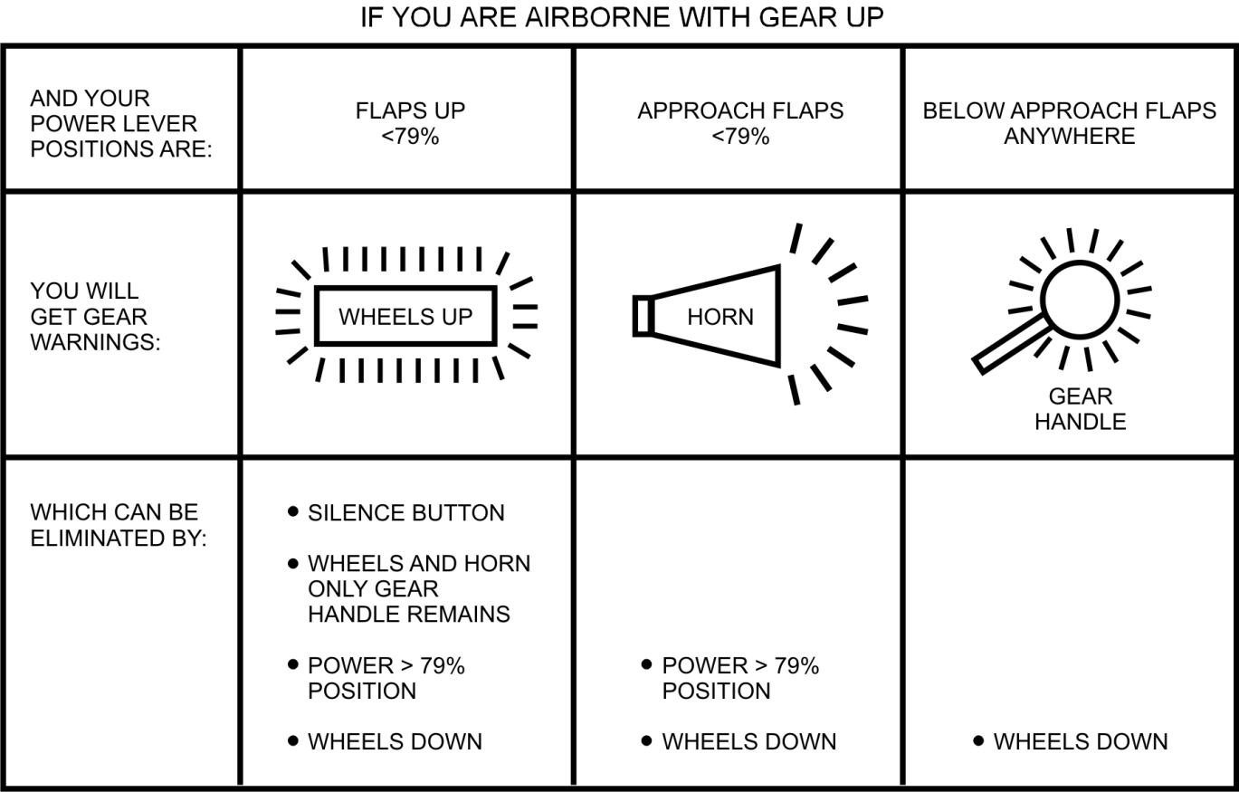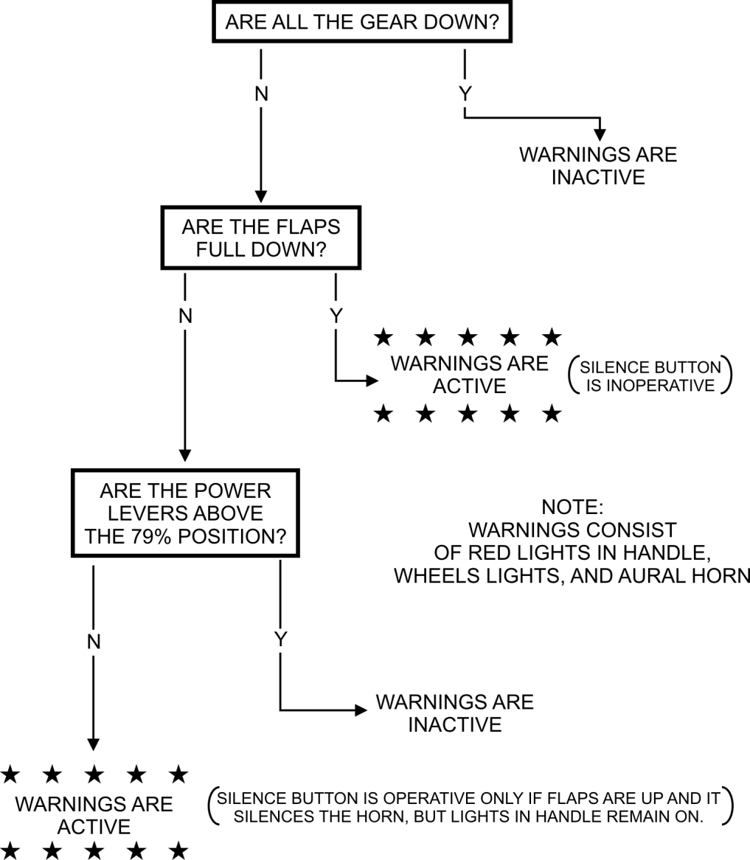
4. Label and describe the operation of the squat switches.
- A squat switch on each main landing gear shock strut controls the operation of various aircraft systems that function only during flight or only during ground operations
- These switches are mechanically actuated whenever the main landing gear shock struts are extended after takeoff or compressed after landing
- Right Squat Switch (HOTSHOTS): When the right strut is compressed (weight on wheels), the right squat switch causes the:
1. Flight hour meter to be inoperative
2. Landing gear circuit to be inoperative
3. Transponder to be inhibited (standby)
4. Stall warning to be deactivated
5. Right engine inlet lip boot heat to be inoperative
6. Operation of some functions of the AHRS/DCU/GPS to be inhibited
7. TAS & Radar to go to STBY
8. Stall warning heat to go to 14V (if turned on)
WARNING: During runway operations, the landing gear handle downlock J-hook may NOT prevent you from raising the handle because of insufficient weight on the right main landing gear squat switch
- Left Squat Switch (LEAP): When the left strut is compressed (weight on wheels), the left squat switch causes
1. Left-engine inlet lip heat to be inoperative.
2. Electric heater to work in ground max mode
3. Ambient air solenoid to close
4. Pressurization controls (safety valve, door seal, preset solenoid, etc.) to go to non-operational mode.
5. Label and describe the operation of the downlock and uplock switches.
- Each landing gear strut has an uplock switch that is closed when each strut is fully retracted. If one or more of the wheel assemblies does not retract fully, the red light in the gear handle will not extinguish
- Check the right gear by checking the PROP SYNC light. If the right uplock is closed (the right gear is fully retracted) the PROP SYNC light will remain extinguished when the prop sync switch is activated.
- Check the nose gear by checking the landing lights. If the nose wheel uplock is closed, the landing lights will not illuminate. If the generator load does not increase after turning on the landing/taxi lights they are not illuminated, thus the nose gear must be closed.
- Check the left gear by checking the electric heater. Normally, when the left uplock switch closes the electric heater will prevent the use of the 4 additional heater elements. To check the left uplock switch in the air, set the electric heater to NORM and note the generator loading. Then set the heater to GRD MAX while monitoring the generator loading. If the loading only fluctuates slightly or shows no significant difference, the left uplock switch is closed and the left gear is fully retracted. If the generator load increases with the electric heater switch set to GRD MAX the left landing gear assembly is NOT fully retracted.
6. Label and describe the operation of the components of the emergency landing gear system.
- 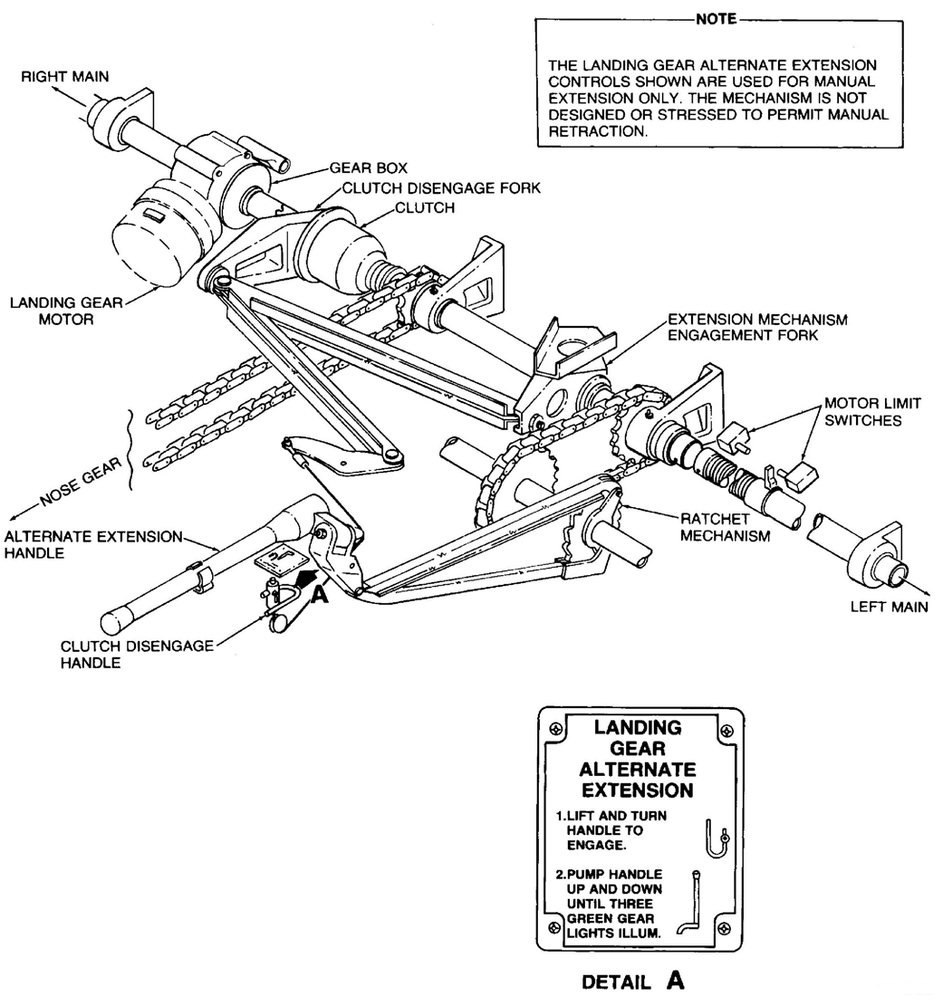
- The landing gear may be manually extended if the electrical mechanism should fail; however, the gear CANNOT be manually retracted and no provision is made for gear extension with a mechanical linkage failure
- CAUTION: If a mechanical malfunction is known or suspected, do NOT attempt a manual gear extension
- Next to the alternate extension handle is the clutch disengage handle. During manual extension: (1) landing gear motor must be disengaged from the landing gear drive mechanism, (2) to disengage the motor, you must lift the clutch handle up and turn it clockwise, (3) then pump the handle until the gear are down
- CAUTION: Reduce handle stroke length when nosegear indicates safe. Do not pump handle after all GEAR DOWN position indicator lights (three) are illuminated. Further movement of the handle could damage the drive mechanism, precluding normal retraction
7. Label and describe the operation of the rudder brake system.
- The main landing wheels are equipped with multi-disc hydraulic brakes actuated by master cylinders and attached to the pilot and copilot rudder pedals
- A shuttle valve, adjacent to each set of pedals, permits braking action change over from one set of pedals to the other.
- Dual parking brake one-way check valves are installed adjacent to the rudder pedals between the master cylinders of the pilot brake pedals and the wheel brakes
- Brake fluid is supplied to the system from the hydraulic brake system reservoir in the nose compartment.
- The toe brake sections of the rudder pedals are connected to the master cylinders which actuate the system for the corresponding wheels
- NO emergency brakes are provided
- 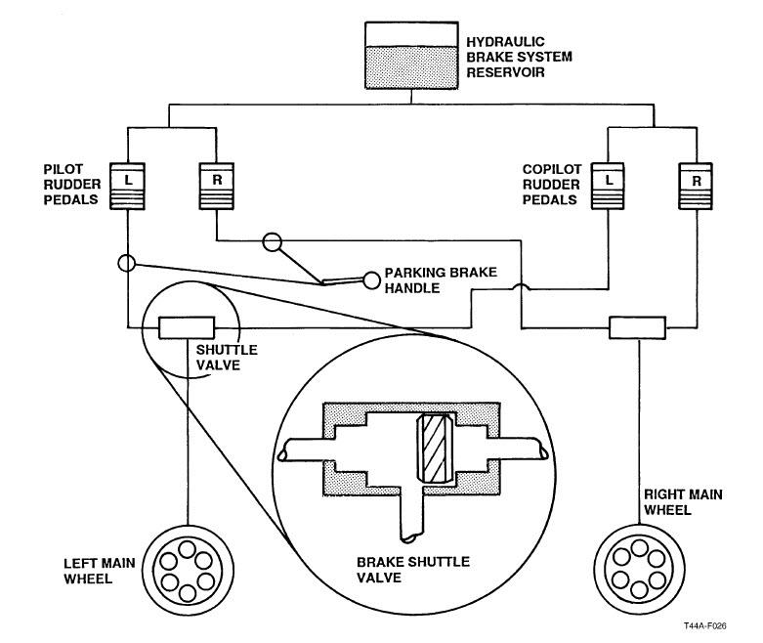

- The recommended airspeed for manually extending the landing gear is 120 KIAS.
- Two landing gear motor limit switches are located on the landing gear drive train assembly underneath the floor of the cabin
  - A gear motor up limit switch deactivates the landing gear motor and prevents overtravel of gear when retracted. This switch also serves to deactivate the g-meters when the landing gear is extended
  - The gear motor down limit switch deactivates the landing gear motor and prevents overtravel of the gear during extension

Chapter 8 - Environmental System

1. Label the components of the environmental system.
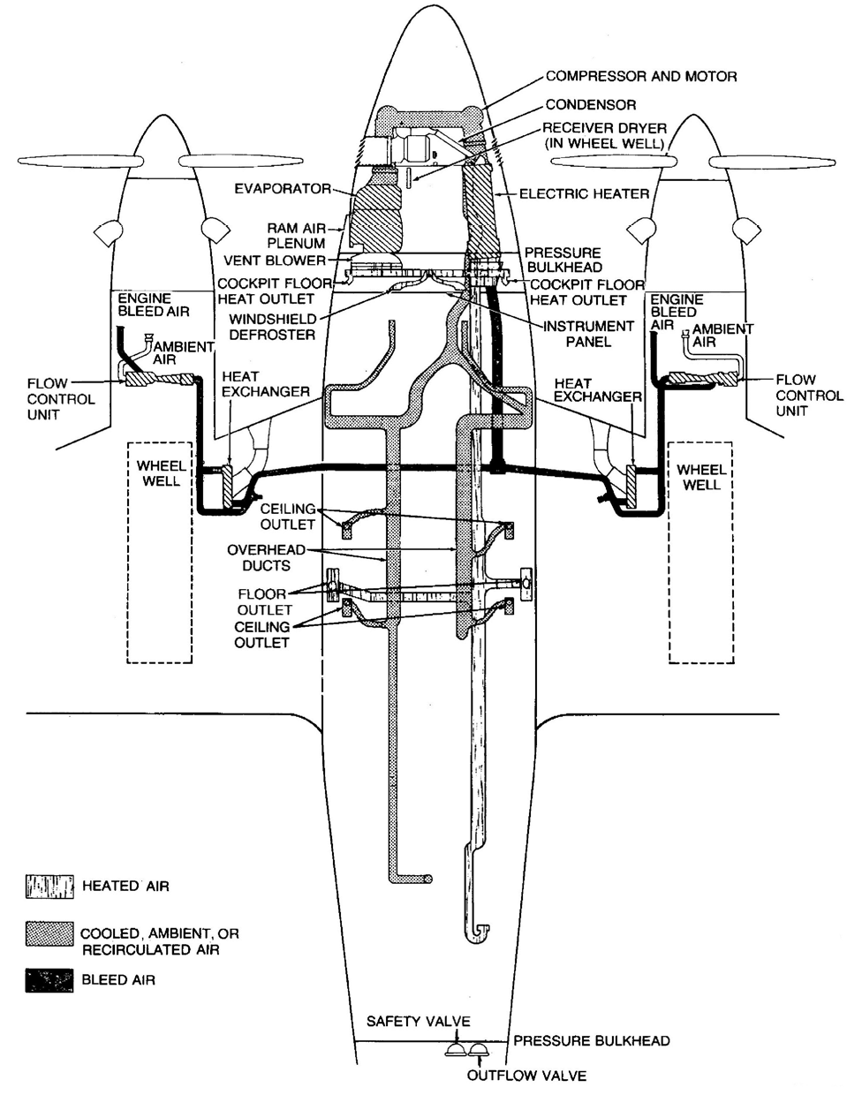
- 1. Cabin Pressure Controller
  - Located on the center console, and pneumatically controls the outflow of air from the cabin
  - Three-position toggle switch:
    - DUMP position, opens safety valve completely to relieve all pressure differential.
    - TEST position, the safety valve closes giving control of the outflow valve to the controller.
    - PRESS position is the normal position for this switch. When the LH squat switch is up (airborne, not activated) and the pressure control switch is set to PRESS, power is removed from a NORMALLY OPEN (N.O.) preset solenoid and a NORMALLY CLOSED (N.C.) safety (dump) solenoid. This action allows the cabin to begin pressurizing at the rate selected on the controller via vacuum forces through the preset solenoid.
  - The controller has two knobs, a rate and altitude knob:
    - The rate knob allows you to control cabin rate of climb from approximately 50 fpm to 2,000 fpm
    - The altitude knob allows you to select the desired cabin pressure altitude from 1,000 feet below sea level to 10,000 feet msl.
- 2. Dual Cabin Altimeter
- 3. Cabin Rate of Climb Indicator
  - Displays actual cabin rate of climb or descent from 0 to 6,000 fpm
- 4. Outflow Valve
  - Located in the aft pressure bulkhead and does 3 things: 1) Meters the outflow of cabin air in response to vacuum control forces from the controller 2) Contains a pre-adjusted relief valve set to ensure that the cabin differential does not exceed 4.7 PSID 3) Incorporates a negative pressure differential relief diaphragm which prevents the pressure differential from becoming negative. (This means, the cabin altitude cannot be higher than the aircraft altitude.)
- 5. Safety Valve
  - Located in the aft pressure bulkhead and is connected to the cabin pressure control switch and wired through the left landing gear squat switch.
  - When set to DUMP (or the LH squat switch is down and the switch is set to PRESS), the safety valve serves as a dump valve, meaning it completely opens to relieve the entire pressure differential between the external air pressure and the cabin air pressure
  - The safety valve backs up the outflow valve. The safety valve also contains a pre-adjusted relief valve. This valve is set to ensure that differential pressure does not exceed 4.9 psi. (Careful, this is easy to confuse with the pre-adjusted valve in the outflow valve.)
  - It also incorporates a negative pressure differential relief diaphragm, which prevents the pressure differential from becoming negative. The cabin altitude cannot be higher than the aircraft altitude.)
  - The safety valve will close when the:
    - 1. landing gear strut extends (at rotation)
    - 2. cabin pressure switch is set to TEST
    - 3. vacuum source is lost
    - 4. electrical power is lost
- 6. Flow Control Unit
  - A flow control unit is located forward of the firewall in each nacelle. The flow control unit has two functions:
    - 1. Controls the bleed air from the engine to make it usable for pressurization, heating, and ventilation
    - 2. Draws ambient air into a venturi to mix with the bleed air
- Environmental System Operation:
  - Before takeoff with the engines not running, the safety valve is closed, the outflow valve is closed, and cabin altitude equals aircraft altitude
  - After the engine(s) are started, the compressor bleed air is tapped off the manifold at a T-fitting as pneumatic air and passed through a venturi to produce a low pressure vacuum. This vacuum holds the safety valve open until take off
  - On take-off, the dump solenoid closes and releases the compressor bleed air vacuum, which closes the safety valve. The preset solenoid opens and a time delay relay is actuated which allows the left engine to commence pressurization sequencing six seconds before the right. The time delay prevents an excessive pressure bump. (A pressure bump occurs when the aircraft pressurizes too quickly.)
  - The flow control unit then mixes engine bleed and ambient air
  - The mixture of engine bleed and ambient air will go through (to cool) or by-pass (for heat retention) a heat exchanger in the wing center section before entering the cabin
  - As the aircraft climbs, the outflow valve begins modulating outflow of air in accordance with the cabin pressure controller to maintain the selected rate of climb and cabin altitude until the maximum cabin differential of 4.7 psid is reached
  - Once the maximum cabin pressure differential is reached, the outflow valve will release air to maintain the maximum cabin differential rather than the setting of the cabin pressure controller. After this point, the cabin altitude begins to climb at approximately the same rate as the aircraft
2. Label and describe the operations of controls that affect cabin temperature.
- 1. Bleed Air Valve Switches
  - Bleed air is the warm, compressed air from the compressor section of the engine and is the primary source of environmental air
  - The bleed air valve switches are placarded BLEED AIR VALVES OPEN - CLOSED. The switches actuate the electric solenoids in the flow control units of their respective engine to send bleed air from the engine to the cabin. A failure of both generators and the main battery will cause the cabin to depressurize as the bleed air valves are electrically held open. Since no more air is coming in and all aircraft will leak, the cabin will slowly depressurize
- 2. Vent Blower Switch
  - The vent blower switch is placarded VENT BLOWER HIGH - LOW - AUTO and controls blower fan speed
- 3. Electric Heat Switch
  - The electric heat switch is placarded ELEC HEAT. The switch has three (3) positions: GRD MAX, NORM, and OFF
  - When in the GRD MAX position and the aircraft is on the ground, the system uses eight (8) heating elements to provide the maximum amount of electrical heat. This setting is used to initially warm up the cabin
  - However, the switch is solenoid held in the GRD MAX position. Once the aircraft takes off, the switch will automatically drop to NORM because the left squat switch de-energizes the solenoid on liftoff
  - In the NORM position, up to four (4) heating elements are automatically turned on and off in conjunction with the cabin thermostat to supplement bleed air heating
  - In the OFF position, all electric heat is turned off and cabin heating is solely provided by bleed air
- 4. Manual Temperature INCR/DECR Control
  - Manual temperature INCR/DECR control is a spring loaded switch placarded MANUAL TEMP INCR - DECR. Whenever the cabin temperature mode selector switch is set to MANUAL HEAT or MANUAL COOL, the INCR/DECR switch controls the motor-driven bypass valves in the wing center sections
- 5. Cabin Temperature Control Switch
  - When the cabin temperature mode selector switch is set to AUTO, the cabin temperature control switch allows you to set the cabin temperature level. The switch works with the temperature sensing units in the cabin to automatically initiate heating or cooling commands to reach the designated cabin temperature. The temperature control switch is marked in units
  - If the automatic temperature control box malfunctions, the CABIN TEMP mode switch can be placed in the MANUAL position and the temperature may be regulated with the INCR/DECR switch. INCR/DECR switch does not operate when the CABIN TEMP mode switch is in AUTO
- 6. Cabin Temperature Mode Selector Switch
  - The cabin temperature mode selector switch has three positions: AUTO, MANUAL HEAT, and MANUAL COOL
  - AUTO position = the temperature sensing units in the cabin initiate heat or cool commands to bring the cabin environment to the desired temperature as set by the cabin temperature control switch
  - MANUAL HEAT position = cabin temperature is manually controlled by the pilot through the manual temperature INCR/DECR control
  - MANUAL COOL position = cabin temperature is manually controlled by the pilot through the manual temperature INCR/DECR control
- Cabin Temperature operation:
  - After generators are operating (or an APU of sufficient capacity is connected), the CABIN TEMP mode switch is set to AUTO, and the cabin temperature control is set to a comfortable temperature
  - With the vent blower switch set to AUTO, the vent blower automatically begins continuous operation
  - With the electric heat switch set to NORM, the air-conditioner or electric heater will function as needed, based on the cabin temperature control switches commands to the bypass valve
  - After the air enters the cabin, it is distributed though the duct system and is recirculated
3. List three (3) items which, when turned on, turn on the electric heater lockout system.
- 1) Windshield Heat 2) Prop De-ice 3) Engine Lip Boot Heat
4. Label and describe the operation of the flow control unit.
- A flow control unit is located forward of the firewall in each nacelle. The flow control unit has two functions:
  - 1. Controls the bleed air from the engine to make it usable for pressurization, heating, and ventilation
  - 2. Draws ambient air into a venturi to mix with the bleed air
5. Label and describe the operation of the controls which affect cabin pressure.
- See above (1)
6. Label and describe the operation of the anti-icing and de-icing system and its components.
- 1. Windshield Wiper System
  - Two electrically operated windshield wipers that are provided for flight and ground operations. CAUTION: Do not operate on dry glass
- 2. Windshield Anti-ice
  - To prevent the formation of ice on the windshields, windshield heat is provided for both the pilot and copilot windshields. A controller with a temperature sensing unit maintains the temperature on the windshield surface at 95 ℉
  - Windshield heat is controlled with the windshield anti-ice switch located on the pilot subpanel. The switch is placarded WSHLD ANTI-ICE BOTH, OFF, PILOT
  - An electric heater lockout will disable the electric heater when windshield heat is in use
  - CAUTION: Unreliable operation of the magnetic compass will occur during use of windshield anti-ice
- 3. Power Plant Ice Protection System (lip boot and ice vanes)
  - Anti-ice protection for each engine is provided by two systems:
    - 1) Mechanically activated engine ice vanes
      - This mechanical system consists of an adjustable push-pull handle for each engine located directly under the pilot's control column. When pushed in the inertial ice vane is retracted in the up position for flight under normal conditions. When pulled out, the vane is extended and locked in the down position. When potential icing conditions are encountered, the pilot can extend the vanes by pulling the two controls placarded: PULL FOR ENGINE ICE PROTECTION, LEFT ENG, RIGHT ENG
      - When the movable vane is extended, lighter air turns abruptly to enter the engine plenum while heavier air (snow, water, ice) rushes past the plenum entrance and is discharged through the bypass duct.
      - 1. Engine Torque decreases approximately 40-60 ft.-lbs.
      - 2. ITT may increase
      - 3. Range will be reduced 10-12%
    - 2) Electrical lip boot heat
      - The electrical anti-ice system consists of an electrothermal boot attached to the air intake lip of each engine
      - Engine lip boot heat is controlled by respective switches on the pilot subpanel placarded ENG LIP BOOT
- 4. Fuel System Anti-ice
  - The fuel system is protected from ice in three areas:
    - 1. With the fuel additive PRIST
    - 2. With the oil-to-fuel heater which automatically heats the fuel
    - 3. Electrical heating elements (or jackets) protect the external fuel vent from ice. This fuel vent is located below each wing and serves both the nacelle and wing tanks
  - The pilot controls the fuel vent, electrical heat jackets with the FUEL VENT switches on the pilot subpanel
  - The pilot controls the fuel control unit pneumatic line, electrical heat jackets with the FUEL CONTROL switches on the pilot subpanel
  - The fuel line heaters are powered by the No. 1 and No. 2 Subpanel Buses
  - CAUTION: To prevent overheat damage to electrically heated anti-ice jacket, FUEL VENT HEAT and FUEL CONTROL HEAT switches should NOT be turned ON unless cooling air will soon pass over the jackets
- 5. Propeller Electrothermal De-icer System
  - To remove ice from the propellers, electrothermal deicing boots are attached to each propeller blade
  - Each thermal boot consists of one outboard heating element and one inboard heating element. The boots receive electrical power through the de-ice timer, slip ring and brush block
  - The pilot controls the propeller deicing boots with the propeller heat switch. The switch is placarded PROP and is located on the right hand pilot subpanel
  - The pilot monitors current consumption through the propeller ammeter on the left hand pilot subpanel
  - The propeller de-ice timer cycles power to the heating elements in this order:
    - 1. RH propeller, outboard segments (all 3 blades)
    - 2. RH propeller, inboard segments (all 3 blades)
    - 3. LH propeller, outboard segments (all 3 blades)
    - 4. LH propeller, inboard segments (all 3 blades)
    - All above segments are heated 34 +/-6 seconds. Normally, this requires more than two minutes to complete all four segments of one cycle
    - Each propeller blade boot draws approximately 5 to 6 amps of current. Thus, with three blades drawing power, the propeller amperage should read between 14 to 18 amps
- 6. Pitot and Stall Warning Anti-ice Systems
  - The pitot tubes and stall warning have electrical heating elements.
  - On the deck, electrical power to the stall heating elements is reduced to 28 Vdc to 14 Vdc.
  - Pitot heat can be used on the deck for short periods to check their operation. Prolonged heating on the deck would cause damage to the pitot tubes
  - The pilot controls these heating elements through the PITOT and STALL SYS switches located on the anti-ice/de-ice control panel
  - In the event of an electrical overload, the circuit breaker will disconnect the heating circuit and trip the toggle switches to the down position
  - CAUTION: Except during takeoff roll, pitot heat should NOT be used while the aircraft is on the ground. Overheating because of lack of cooling airflow will damage the heating elements
- 7. Surface De-icer System
  - De-ice boots protect the leading edges of each wing, both horizontal stabilizers and the vertical stabilizer. They are pneumatically actuated and flex to break ice accumulation on these surfaces
  - Engine bleed air, from the engine compressor, is used to supply air pressure to inflate the de-ice boots and to supply a vacuum through the distribution valve to hold the boots down during flight
  - The de-ice boots are controlled by the three position DEICE CYCLE switch:
    - 1) SINGLE position, the de-ice boots inflate for 7 to 8 seconds and then automatically return to the deflated position
    - 2) MANUAL position, the de-ice boots inflate for as long as the switch is in the MANUAL position.
    - 3) OFF position, the de-ice boots are deflated
7. Label and describe the operation of the oxygen system and its components.
- Designed primarily as an emergency use system, but may also be used to provide supplemental oxygen at cabin altitudes above 10,000 feet. The system consists of:
- 1. Oxygen Supply Cylinder
  - The 49 cu.ft. oxygen supply cylinder is installed behind the aft bulkhead. A full cylinder contains oxygen at a pressure of 1850 psi +/- 50 psi at a temperature of 70 ℉
- 2. Pressure Regulator Control Valve
  - It is connected to the oxygen supply cylinder. This valve is controlled by a remote push-pull knob located on the overhead panel in the cockpit
- 3. Oxygen Supply Pressure Gauges
  - An OXYGEN SUPPLY PRESSURE gauge is located on the oxygen service panel on the right side of the fuselage. The gauge is next to the filler valve
  - In the cockpit, you can monitor the oxygen cylinder pressure through the OXYGEN SUPPLY PRESSURE gauge on the copilot right side panel
- 4. Outlets
- 5. Oxygen Masks
  - Diluter-Demand Oxygen Masks are available for the pilot, copilot and observer
  - The oxygen masks are diluter-demand/100% regulator masks. They provide the proper dilution of oxygen with cabin air to conserve oxygen at lower altitudes. A visor is also provided on the mask
  - Each diluter-demand mask has a pressure detector/indicator in the oxygen system line to provide a visual indication of oxygen flow.
  - A green signal indicates adequate oxygen flow
  - A red signal in the window of the detector indicates low or no oxygen flow
  - Each diluter-demand mask has a microphone. Set the MIC switch on the audio panel from “BOOM” to “MASK”
- 6. Diluter Control Lever
  - The diluter control lever allows you to control the mix of oxygen and air in the mask
  - In NORMAL position, the regulator automatically schedules a proportional increase in oxygen as the altitude increases
  - In the 100% position, 100% oxygen will be provided upon inhalation, regardless of altitude
  - At cabin altitudes below 20,000 ft., the lever should be placed in the NORMAL position to conserve oxygen if used for supplemental O2
  - When not in use, the masks should be stowed with the diluter lever in the 100% position
  - EMER control setting, provides 100% oxygen at a positive pressure to the mask and will purge the mask and visor
8. List five (5) items that, when in use, cause the wet compass to be erratic.
- 1) Windshield Anti-ice 2) Windshield Wipers 3) Air-conditioner 4) Electric Heat 5) Vent Blower

Chapter 9 - Flight Instruments

1. Label and describe the operation of the primary flight displays (PFD).
- The pilot and copilot PFDs are DC powered respectively through the No. 1 and No. 2 avionics buses
- They provide the pilot and copilot with attitude, navigation, altitude, airspeed, radio altimeter, vertical speed, selected flight director modes and hazard avoidance including weather radar and TAS displays
- The top portion displays an attitude director indicator as well as airspeed and altitude tapes
- The bottom portion contains the horizontal situation indicator (HSI) and hazard displays
- 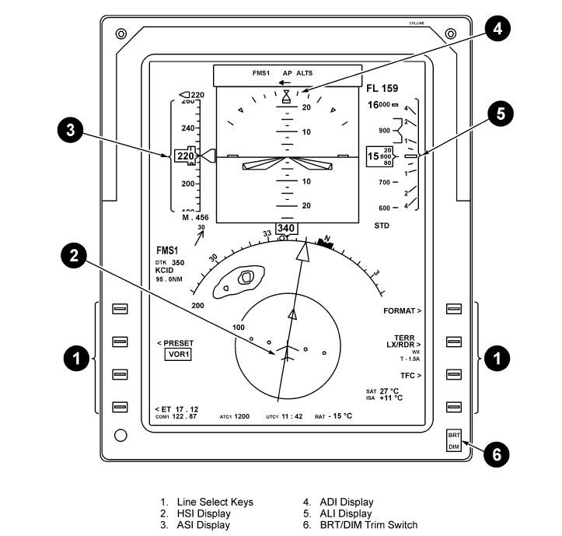

2. Label and describe the operation of the flight guidance panel (FGP).
- The FGP provides the crew with the ability to set the flight director and autopilot modes
- It is also used to set pre-selected altitude, airspeed, heading, and course on the PFDs
- 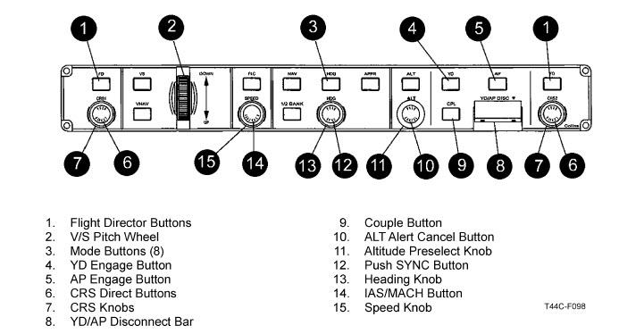
3. Label and describe the operation of the display control panel (DCP).
- 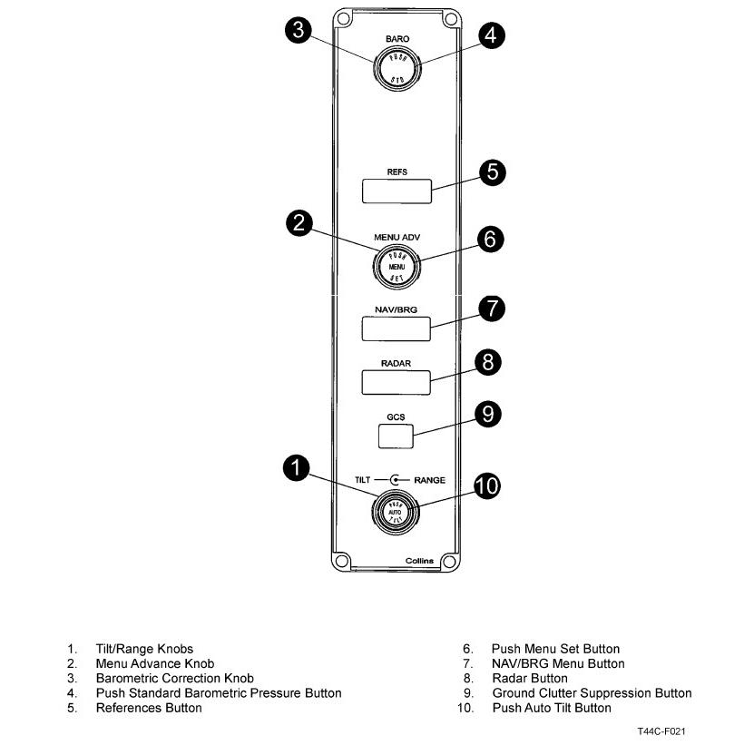
- The pilot and copliot DCPs are used to select altimeter settings, navigation needles, and weather radar modes
4. Label and describe the operation of the air data computers (ADC).
- There are three air data computers on the T-44C: one each for the pilot and copilot PFDs and one internal to the ESIS. The computers process the pilot-static inputs to provide a digital display of airspeed, altitude and vertical speed
5. Label and describe the operation of the attitude heading reference systems (AHRS).
- There are two attitude heading reference computers that send information to the pilot (AHRS1) and copilot (AHRS2) primary flight displays, and the ESIS heading tape (AHRS1)
6. Label and describe the operation of the reversionary panel.
- The Reversionary Panel provides the crew with the ability to select alternate ADC and AHRS sources in the event of a failure. The panel also contains two switches that select the COM/NAV input source (RTU or CDU) that should be selected to normal. If the switches are in any other position you will lose the ability to tune to through both sources
7. Label and describe the operation of the pitot-static system.
- 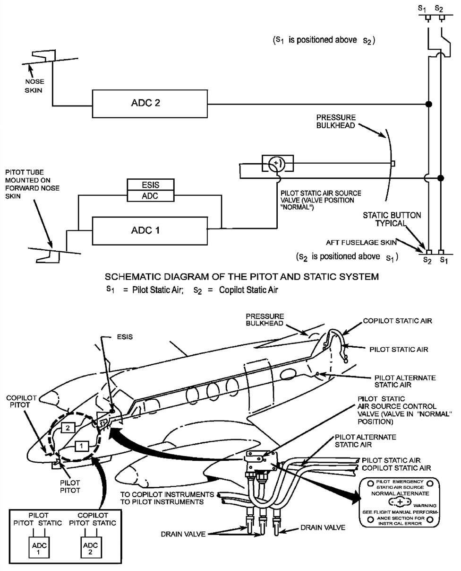
- The pitot static air system provides two (2) separate sources of static and ram air to the ADCs displaying airspeed, altitude, and vertical speed on the PFDs. The Pitot-Static System includes:
  - 1)Two internally heated pitot masts mounted on either side of the nose
  - 2) Four static air pressure ports, two on the aircraft exterior skin on each side of the aft fuselage
- The port pitot tube provides a reference for ADC1 and the ESIS ADC
- The starboard pitot tube provides a reference for ADC2
8. Label and describe the operation of the electronic standby instrument system (ESIS).
- The ESIS is powered by the avionics essential bus which in an emergency can be powered by a 24Vdc, 5 amp-hr auxiliary battery. It receives heading information from AHRS1 and has its own ADC and 3 axis inertia sensor for pitch, roll, and slip/skid. It is capable of providing attitude, heading, airspeed, VSI, altitude, and VOR or ILS course guidance from NAV1
- WARNING: If AHRS1 fails a "DG" warning will appear above the heading tape and heading is now subject to precession error. A “set heading” option will now be available on the ESIS menu allowing manual updates to the ESIS heading tape
- 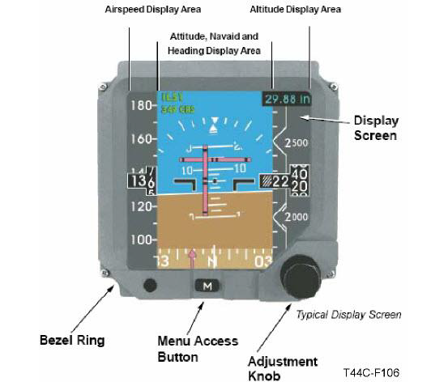
9. Label and describe the operation of the turn and slip indicator.
- The turn and slip indicator is vacuum operated using pneumatic air
- One needle width on the turn and slip indicator indicates a standard rate turn
10. Label and describe the operation of the standby compass.
- The standby compass is located on top of the windshield divider. The standby magnetic compass can be used in the event of complete AHRS failure or AHRS1 failure during ESIS operation
- NOTE: When using the standby compass turn off windshield anti-ice, windshield wipers, air-conditioner, electric heat, and vent blower
11. Label and describe the operation of the radio altimeter.
- The radio altimeter provides accurate above ground level (AGL) altitude indications anytime the aircraft is below 2500 AGL. The crew can input desired settings using the DCP and when the aircraft descends to that setting, a "MIN" annunciator will illuminate next to the VSI display on the PFDs and an aural cue will be heard
- To test the radalt: Press the button on the overhead panel. A radio altitude of 50 +/- 5 ft will be displayed, the MIN box will illuminate, and the radalt bar will come up to 50 +/- 5 ft
12. Label and describe the operation of the stall warning system.
- The stall warning system consists of a lift detector unit on the left wing, a stall warning annunciator, and a warning horn.
- To test the stall warning: Activate the stall test switch on the pilot subpanel which will illuminate the annunciator and sound the horn
13. Recognize the indications and potential results of a loss of DC power to the flight instruments.
- If you lose DC power the NATOPS will direct you to ensure the AUX/BATT is armed. This will ensure power to the Avionic Essential Bus which powers the following:
  - 1) COM1
  - 2) RTU
  - 3) PLT AUDIO
  - 4) NAV1
  - 5) ESIS
  - The CRANE acronym may be used to remember these items

Chapter 10 - Avionics

1. Label and describe the operation of the flight management system (FMS).
- 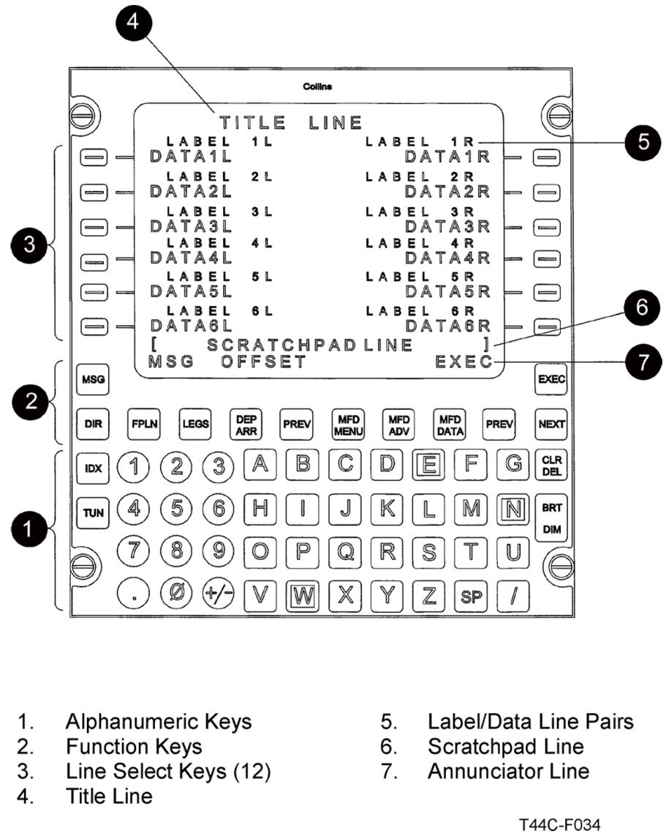
- Comprised of the Control Display Unit (CDU) and the FMS computer. The system blends inputs from the VORs, DME, and GPS to compute present position
- The Control Display Unit (CDU) receives power from Avionics Bus No. 2 and is located on the forward right portion of the center pedestal. The CDU allows pilot to enter and modify flight plans and tune most Com/Nav equipment. The most commonly used keys are:
  - TUN- allows the crew to remotely tune and select modes for the COM1, NAV1, NAV2, DME HOLD, ATC, & ADF. (NAV1&2 receive VOR and LOC frequencies only)
  - IDX- allowed the crew to access the GPS CTL (for deselecting satellites and checking RAIM), HOLD, and ROUTE MENU (for stored Seagull and Low level routes)
  - FPLN- displays the primary and secondary flight plan pages
  - LEGS- displays the flight plan points and is used to modify the route in flight
  - DEP ARR- allows the crew to enter departures and arrivals (SID, STAR, and IAP)
  - PERF- allows the crew to select cruise altitude
  - MFD MENU- selects the desired display on the PFDs such as airports, navaids, and ETA. This function is not available in the T-44C
- The FMS computer provides the blended solution for navigation and provides remote tuning. To identify the current Nav solution press IDX, then STATUS
2. Label and describe the operation of the radio tuning unit (RTU).
- The radio tuning unit (RTU) is powered by the Avionics Essential Bus and is located on the center instrument panel. The RTU provides the crew the ability to tune and select modes for the following: COM1, NAV1, NAV2, ATC, ADF
- 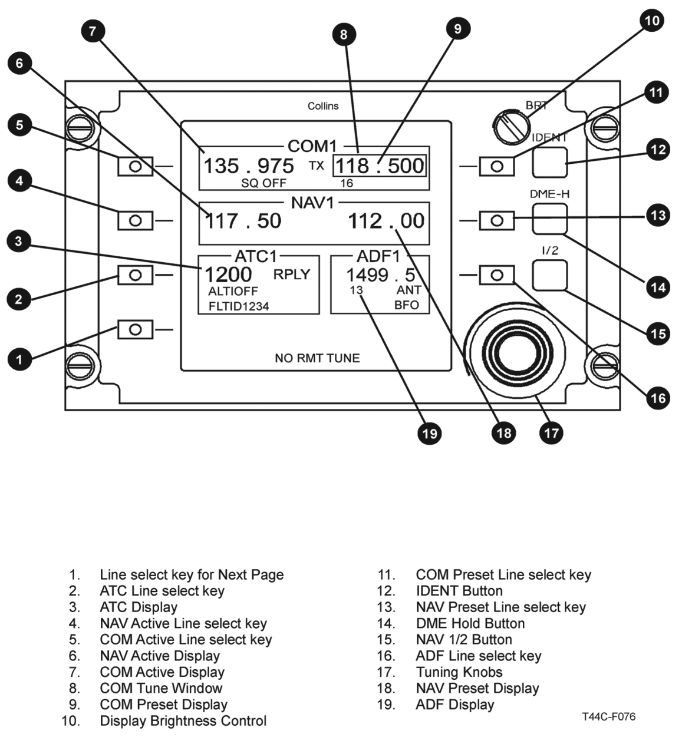
3. Label and describe the operation of the V/UHF.
- 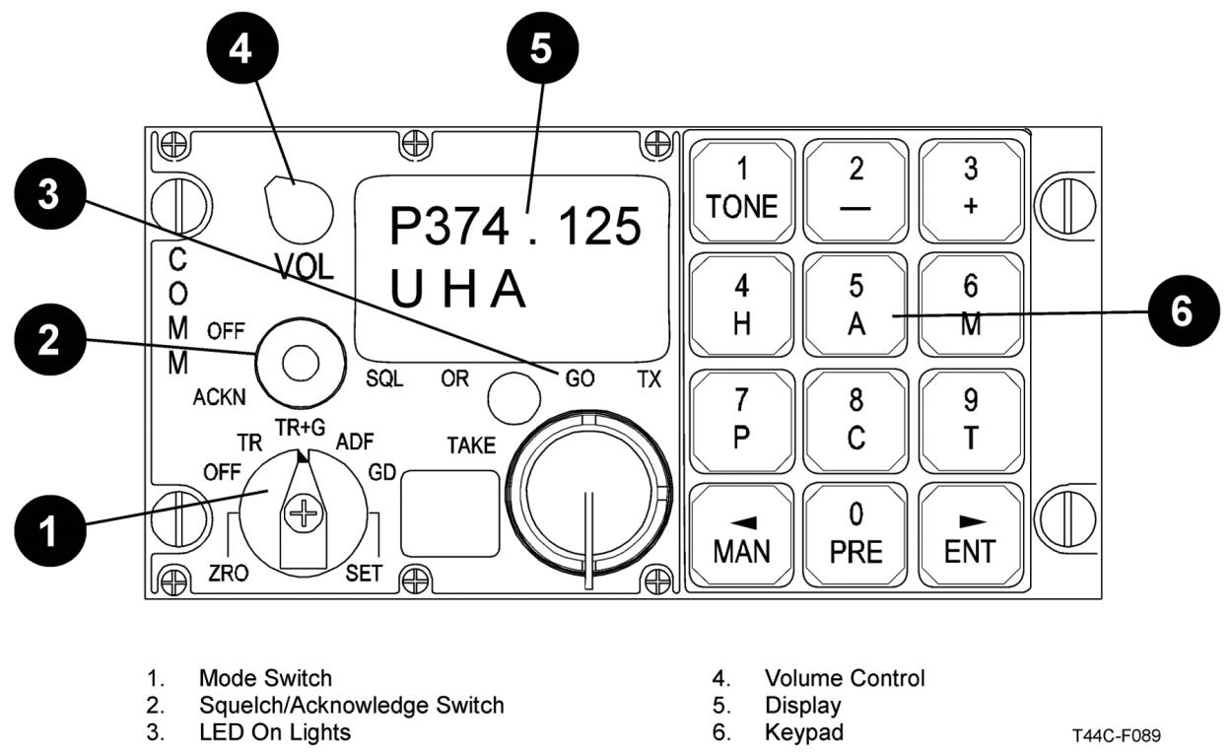
- The V/UHF is powered by the Avionics Bus No. 2 and is located on the center instrument panel above the RTU. The V/UHF is used to tune 1 of 20 UHF presets channels or to manually enter VHF and UHF frequencies
- In normal operation the bottom of the display should read "U↑Am" which means that UHF Guard is monitored, high power output, and AM plain mode
4. Label and describe the operation of the TACAN, VORs, DME, ADF, FMS, and Comm radios.
- The TACAN is powered by the Avionics Bus No. 1 and is tuned through the TACAN Control Panel on the center pedestal using the channel selector knobs and the "X/Y" switch. The AA/AG switch (air to air or air to ground) is normally in the A/G position unless mission dictates (formation and air refueling)
5. Label and describe the operation of the components of the audio control panels.
- 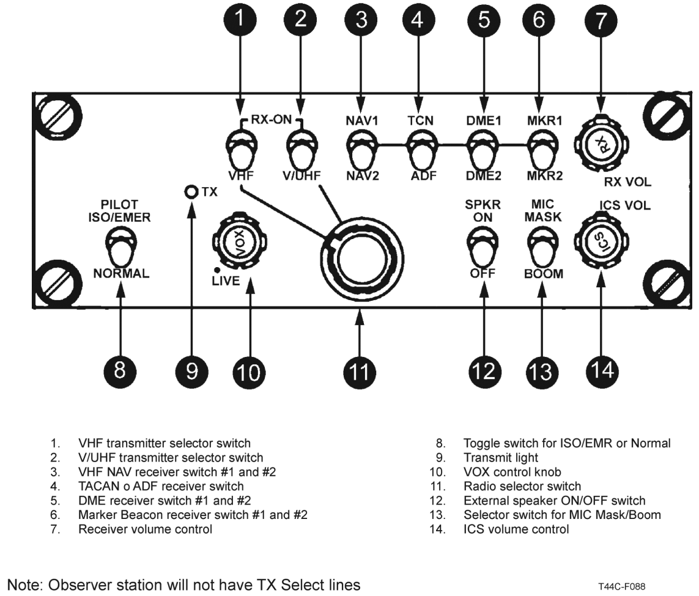
- There are three audio control panels; one each for the pilot, copilot, and observer. They are powered by the Avionics Buses 1, 2, & 3 respectively. The observers ACP does not provide transmit capability
6. Label and describe the function of the flight guidance system (FGS).
- The Flight Guidance System (FGS) is comprised of two Flight Guidance Computers (FGC), a Flight Guidance Panel (FGP), and four servos. The FGS provides the crew with autopilot, flight director, and electric pitch trim
- Flight Director:
  - The flight director (FD) provides pitch and roll guidance based on crew inputs on the FGP. To engage the FD select the desired mode on the FGP. Ensure that the FD is coupled to the PF's side using the CPL key which will display ← or → on the ADI. Commonly used modes:
    - HDG- Used to capture and maintain selected heading.
    - NAV- Used to capture the primary nav source on the coupled side.
    - APPR- Used to capture the final approach course and glideslope (ILS) or glidepath (LNAV/VNAV) on a precision approach
    - ALT- Used to preselect the desired altitude. Push the knob in and turn for 100 ft increments
    - FLC- Captures the current IAS and directs a climb or descent to the preselected altitude. Normally climb at 150KTS below 10,000 ft. and descent speed is at pilot discretion
    - VS- Commands a constant VSI as set on the VS pitch wheel
    - VNAV- Enables vertical navigation modes.
    - Autopilot: The autopilot servos position the aircraft control surfaces in response to steering commands from the FGS. The autopilot also drives the pitch trim system and can be engaged by putting the YD/AP DISC switch bar in the up position and pressing the AP button on the FGP
    - The autopilot may be engaged at 400 AGL on departure, 1000 AGL at cruise, and shall be disengaged by 180AGL on approach. The autopilot should be disengaged by the red AP/YD switch on the control yoke or by putting the YD/AP DISC switch bar in the down position to ensure that the yaw damper is also disengaged
7. Label and describe the Hazard Avoidance Systems (MFD) and weather radar.
- The MFD is powered by the Avionics No. 3 bus and receives position information from the GPS which enables it to display:
  - 1) Moving map 2) Enhanced Ground Proximity Warning System (EGPWS) 3) TAS information
  - The traffic advisory system (TAS), powered by the Avionics No. 3 bus, includes a processor and antennas, allowing traffic alert and information from aircraft equipped with transponders to be displayed on the MFD and both PFDs
  - An open white diamond- Indicates non-threat traffic (greater than +/- 1200' or 5NM.)
  - A filled white diamond- Indicates traffic in the proximity (within +/- 1200' and 5NM)
  - A filled yellow circle- Indicates a traffic advisory (TA) (flight paths intersecting within 15-30 sec)
  - All three symbols incorporate an altitude tag displaying relative attitude in 100's of feet if the relative mode is selected.
  - Relative altitude modes:
    - 1) Normal: +/- 2700'
    - 2) Below: -9000' to +2700'
    - 3) Above: -2700' to +9000'
    - 4) Unrestricted: +/- 10000'
  - To display the TAS on the PFD the TFC overlay must be selected.
  - Enhanced ground proximity warning system (EGPWS) has three annunciators:
  - 1) PULL UP Warning: flight path within 30 seconds of terrain
  - 2) TERRAIN Caution: continuing current flight path could result in terrain impact
  - 3) TERRAIN N/A: no position reference
  - See NATOPS Chapter 15 for Terrain Warning Procedures
  - The T-44C is equipped with a Turbulence Weather Radar powered by the Avionics No. 3 Bus and can only be displayed on the PFD. The weather radar antenna is located in the nose of the aircraft and can detect precipitation (WX mode) up to 300 NM and turbulence (WX+T mode) up to 50 NM. To display the radar: the PFD must be in 120 or 120 map mode and the RDR overlay selected
    - Weather Radar (WX) key is disabled on the MFD
8. Recognize the indications and potential results of a loss of DC power to the COMM/NAV equipment.
- If you lose both generators the NATOPS will direct you to ensure the AUX/BATT is armed. Arming the AUX/BATT will ensure power to the Avionic Essential Bus which powers the following:
  - 1) COM1 2) RTU 3) PLT AUDIO 4) NAV1 5) ESIS (CRANE)

