C4204

DISCUSS ITEMS
Aircraft operating limits, forced landing, fuel system, and environmental/pressurization system.

Aircraft Operating Limits
Engine [Ref (NATOPS Fig 4-2)]
- ITT
- Torque
- Turbine Tachometer (N1)
- Propeller Tachometer (N2)
- Oil Temp & Pressure
Airframe [Ref (NATOPS Fig.4-4)]
- Airspeeds
- Accelleration
- Altitude
- Center of Gravity
- Weight
- Landing
- Pressurization

Forced Landing
- Site Selection
- Configuring
16.7 FORCED LANDING — NO POWER
If sufficient altitude remains after reaching a suitable landing area, a circular pattern will provide best observation of surface conditions, windspeed and direction. When the condition of the terrain has been noted and the landing area selected, set up a normal pattern and extend the gear when the landing is assured. Fly the base leg as necessary to control point of touchdown. Plan to overshoot rather than undershoot using flaps as necessary. Keep in mind that with both propellers feathered, the normal tendency is to overshoot because of less drag. In the event a positive gear down and locked indication cannot be determined, prepare for a gear up landing.
Note
Night emergency egress may be facilitated by pre-positioning the threshold and spar lighting switch to on and turning on the aft compartment lighting.
1. Configuration
a. Do not extend full flaps until the landing is assured.
b. A gear up landing should be considered based on the type of touchdown surface.
2. Selecting a landing area
a. Select a landing area of adequate size to accommodate the aircraft, preferably free of obstacles and smooth. Cultivated fields are most desirable. Swamps, boggy ground, shallow lakes, and forest should be avoided if possible.
b. Land aircraft into the wind as near as possible.
3. Landing the aircraft
a. The landing should be made at the slowest speed commensurate with complete control.
b. If landing into trees, fly into them. Do not attempt to land on the tops.
To assist the pilot in making a forced landing, a pattern describing optimum altitudes at selected positions is provided (Figure 16-5). This diagram has been included for information purposes only and is not considered a training objective for qualification in the aircraft.

Fuel System
- Types
- Capacity
- Drains/Vents
- Transfer Pumps
- Boost Pumps
- Crossfeed Valve
- Quantity Indicators
- Annuciator Lights
- Emergencies
3.2.1 Type of Fuel
The primary fuels for the T-44C are JP-4, JP-5, JP-8, F-24, Jet A, Jet A1 and Jet B. Consult the fuel reference charts (Figure 3-2). Commercial jet fuels do not contain anti-ice/fungicide (PFA55MB, MIL-I-27686, or equivalent). When commercial fuels are procured, fuel thickening may occur when temperatures are less than -40 °F and long-term fungus control may be degraded. When adding commercial jet fuel in quantities greater than 104 gallons (approximately 700 pounds) in each wing, 20 fluid ounces of anti-ice/fungicide additive (PRIST) should be added to each wing when required. PRIST should be added gradually during filling to permit increased blending in the fuel.
CAUTION
• JP-8+100 shall not be used in the T-44C. This fuel will clog the fuel filter.
• PRIST injected into the fuel from aerosol cans as it is pumped into the aircraft is not recommended. It does not mix well with the fuel, has a tendency to settle to the bottom of tanks, and may damage fuel system seals and fuel tank materials.
Note
If PRIST is injected via aerosol cans, special attention should be paid to low point drain samples for signs of deteriorating fuel cells, i.e. fuel cell coatings, bladder material, or corrosion-born material. Injection of aerosol PRIST increases the risk of deterioration.
Request refueler assistance for proper fuel/additive blending during the aircraft refueling. The following procedure will be utilized when blending anti-icing additive, complying with MIL-I-27686, as the aircraft is being refueled through wing fillers.
1. When using HI-FLO PRIST blender (model PHF-204), remove the cap retaining tube and clip assembly.
2. Attach pistol grip on collar.
3. Press tube into button.
4. Clip tube end to fuel nozzle.
5. Pull trigger firmly to assure a full flow capability and lock in place.
6. Start flow of additive when refueling begins. (Refueling should be at 50 gal/min minimum and 60 gal/min maximum.) A rate of less than 30 gal/min may be utilized when topping off tanks.
CAUTION
Ensure that the additive is directed into the flowing fuel stream and that additive flow is started after fuel flow starts and is stopped before fuel flow stops. Do not allow concentrated additive to contact the coated interior of fuel cells or aircraft painted surfaces. Use no less than 20 fluid ounces of additive per 260 gallons of fuel added or more than 20 fluid ounces of additive per 104 gallons of fuel added.
In the event aviation kerosene is not available, aviation gasoline grades 80/87, 100/130, 100LL, or 115/145 are approved emergency fuels.
Note
Aviation gasoline contains a form of lead that has an accumulative adverse effect on turbine engines. The lowest octane (AVGAS) available (lowest lead content) should be used.

2.9 FUEL SYSTEM
The fuel system supply (Figure 2-5) consists of two identical systems sharing a common fuel management panel and a continuous stainless steel crossfeed line that passes through the pressure vessel just forward of the main spar. The fuel for each system is contained in a 61-gallon nacelle tank and four interconnected wing tanks that total 132 gallons. The total fuel system capacity is 387.6 gallons of which 384 gallons are usable (192 gallons each system). A crossfeed system permits the use of fuel from all tanks by either engine and is controlled by an electrically actuated valve in the crossfeed line. Fuel is gravity fed from the three outboard tanks to the center section tank where the fuel is then transferred to the nacelle tank via the submerged transfer pump. The transfer pumps are energized and deenergized by 42-gallon (ON), 51-gallon (OFF), and 59-gallon (upper level) float switches in the nacelle tank. Fuel is used from the nacelle tank until the 42-gallon switch position on the level sensor float is actuated which causes fuel transfer to start. When the fuel quantity reaches the 51-gallon switch position, transfer action is terminated. Unless the pilot elects to use manual transfer control after the first transfer cycle, all subsequent fuel transfer will maintain nacelle tank fuel quantity at a level between 42 and 51 gallons until all fuel is used from the wing tanks. If fuel transfer into a nacelle tank is not terminated by either the 51- or the 59-gallon upper level float switch, overfill fuel will flow back into the wing tanks through the vent lines. Operation would stabilize into a continuous fuel transfer loop. A continuously full nacelle tank, monitored on the fuel quantity gauge would indicate this condition. While sufficient fuel remains in the wing tanks, the pilot may use manual control to refill the nacelle tanks to capacity by placing the TRANSFER PUMP switch in the OVERRIDE position. Fuel transfer will continue until the switch is positioned to AUTO or OFF. In this instance, the transfer pump shutoff circuits on the float switches are bypassed and the overfill condition previously discussed could result. Should a transfer pump fail in flight, the fuel from the wing tanks will gravity feed to the nacelle tank. As the nacelle tank fuel reaches approximately three-eighths full, a gravity feed port in the nacelle tank opens and gravity flow from the wing tanks starts. All fuel except 28 gallons from each center section tank will transfer during gravity feed.
2.9.1 Fuel Tank Sump Drains
Fuel system tanks and interconnect lines may be drained of moisture condensate and sediment at the system low points on the nacelle tanks, wing tanks, wheelwell sumps, transfer pumps, and at the fuel strainers in the engine compartment.
2.9.2 Fuel Vents
The fuel vents for both nacelle and wing tanks are protected against icing conditions by electric heating elements. In addition to external heated vents, each fuel system has a flush vent in the underside of the wing. Volume expansion in the fuel system is relieved by a thermal pressure relief valve. Normally, thermal expansion occurs only during hot weather when the aircraft is static on the ground. The left and right fuel vent heaters are actuated with the respective circuit breaker switches placarded FUEL VENT, LEFT, RIGHT and located on the pilot inboard subpanel.
2.9.4 Fuel Transfer Pump
Automatic transfer cycles will then maintain the nacelle quantity between 42 and 51 gallons until all wing fuel is depleted. When all wing tank fuel has been used, a pressure sensing switch will sense the drop in fuel pressure in the transfer line and, after a 30-second delay, will terminate transfer pump operation, and a red NO FUEL TRANSFER annunciator light will illuminate. The NO FUEL TRANSFER light also functions as an operation indicator for the transfer pump. If the light should illuminate before the wing fuel is depleted, the transfer pump has stopped transferring fuel to the nacelle tank. Extinguishing the NO FUEL TRANSFER light is accomplished by placing the transfer switch to OFF. The transfer pumps receive power through and are protected by the circuit breakers placarded TRANSFER PUMP located on the lower edge of the fuel management panel.
Note
If the wing tank is gravity feeding to the nacelle tank, then the nacelle tank will have approximately 150 pounds of fuel (below the yellow arcs).
Note
The nacelle tank must contain at least 42 gallons of fuel for a proper test of the respective transfer pump.
2.9.4.3 NO FUEL TRANSFER Indicator Lights
CAUTION
• Illumination of a no fuel transfer light may indicate failure of the associated transfer pump during any condition of fuel transfer or fuel availability.
• Reliance of the secondary capability of the NO FUEL TRANSFER light to indicate fuel remaining should never be substituted for careful fuel planning.
• The LH and RH NO FUEL TRANSFER lights are powered by the No. 1 and No. 2 fuel buses, respectively, and are activated through the respective transfer pump circuit breaker. If the transfer pump circuit breaker fails, the respective transfer pump will cease to operate and the associated NO FUEL TRANSFER annunciator light will not illuminate.
2.9.5 Boost Pumps
It is the function of the submerged boost pump in each nacelle tank to deliver pressurized fuel to the inlet of the engine-driven fuel pump on each engine. Normal engine operation may be maintained with only the engine-driven pump (suction lift). However, if the engine-driven pump fails, flameout will occur. With the crossfeed switch in the AUTO position, failure of a boost pump is indicated by a momentary illumination of the LH or RH FUEL PRESSURE light, a flashing FAULT WARNING light, and steady illumination of the FUEL CROSSFEED light. Since the LH or RH FUEL PRESSURE light rapidly extinguishes as autocrossfeed commences, the pilot may be first alerted only by the FUEL CROSSFEED light illumination and/or flashing FAULTWARNING light. The failed boost pump can be identified by momentarily placing the crossfeed switch to the CLOSED position. The red LH or RH FUEL PRESSURE light will illuminate indicating the failed boost pump. The boost pumps are powered by both their respective fuel bus and the hot battery bus. Fuel bus circuit protection is provided by circuit breakers placarded BOOST PUMP on the fuel management panel. Circuit protection for the hot battery bus is provided by fuses located under the right wing root.
2.9.6 Fuel Crossfeed
Crossfeed does not transfer fuel from one tank system to the other. Crossfeed allows one engine to receive fuel from the opposite tank system. If one engine is inoperative and it is desired to use fuel from the opposite system, use the SINGLE ENGINE CROSSFEED procedure in paragraph 15.5. The fuel crossfeed valve normally receives its electrical power from the No. 1 fuel bus; however, in the event of a fuel bus failure, the valve is also connected to the hot battery bus. The circuit is protected by a circuit breaker placarded CROSSFEED VALVE located on the fuel management panel. To remedy an imbalance in the fuel load, with the crossfeed switch in the OPEN position, place the boost pump switch for the system with less fuel to the OFF position. Should a situation arise where a boost pump fails and the crossfeed switch is in the AUTO position, automatic crossfeed will start. With a boost pump inoperative, the engine is capable of operating from its own fuel supply on engine-driven pump pressure (suction lift) only. This is accomplished by placing the crossfeed switch in the CLOSED position.
CAUTION
Engine operation using only the engine driven fuel pump without boost pump fuel pressure is limited to 10 hours throughout its TBO period. All such time shall be entered on the appropriate maintenance form for attention of the maintenance personnel.
Note
Do not operate with the crossfeed in the OPEN mode with both boost pumps operating. Fuel may be inadvertently crossfed from either fuel system to both engines because of normal variances in pump pressure.
Note
In the event a crossfeed valve closes because of malfunction, the FUEL CROSSFEED light may remain illuminated. The same circuit that opens the crossfeed valve also illuminates the FUEL CROSSFEED light.
CAUTION
Do not use the fuel firewall shutoff valve to shut down an engine except in an emergency. The engine-driven high pressure fuel pump obtains essential lubrication from fuel flow. When an engine is operating, this pump may be severely damaged (while cavitating) if the firewall valve is closed before the condition lever is moved to the FUEL CUTOFF position.
2.9.8 Fuel Quantity Indicators
WARNING
• Fuel quantity indication error may be significant with either TOTAL or NACELLE position selected. Do not use the fuel quantity indicators solely to determine quantity of fuel remaining. Refer to Part XI Performance Data.
• Flameout is possible due to fuel starvation with a fuel quantity indicator reading as high as 150 lbs.
15.10.1 Engine-Driven Fuel Pump Failure
Flameout. EMERGENCY SHUTDOWN CHECKLIST.
15.10.2 Transfer Pump Failure
Wing tank empty? Try Override. Else 28 Gal unusable. Gravity feed, Nacelle at 150lbs.
15.10.3 Boost Pump Failure
Crossfeed, less fuel. Suction Lift, less reliable. Boosted pressure on approach/landing.
15.11 FUEL LEAKS
Concern is Engine Fire. Consider securing electrical systems.
Outboard: Nav Lights, Strobe Lights, Fuel Vent Heaters, Lift Detector and Heater (L)
Inboard: Gangbar.
Consider securing the engine as follows
†*1. Condition lever — FUEL CUTOFF.
*2. Emergency Shutdown Checklist — Execute.
15.12 FUEL SIPHONING
140KTS. Avoid Nose Low.

Environmental/Pressurization System
- Flow Control Unit
- Heating v Cooling
- Px Controls
- Px Valves
2.18 ENVIRONMENTAL SYSTEM
An environmental control section on the copilot subpanel (FO-1) provides for automatic or manual control of the environmental system (Figure 2-18). This section, just to the right of the landing gear control, contains all the major controls of the environmental system: bleed air valve switches, vent blower control switch, manual temperature control switch, electric heat mode switch, cabin temperature control rheostat, and the mode selector switch for selecting manual or automatic heating or cooling.
2.18.1 Bleed Air Valve Switches
Bleed air valve switches of the two-position, lever-lock type, placarded BLEED AIR VALVES — OPEN — CLOSED, actuate electric solenoids in the flow control units of the engines to bring warm, compressed air (bleed air) from the compressor section of the engine to the cabin. The bleed air valve solenoids receive electrical power through the No. 1 and No. 2 feeder buses and are protected by the circuit breakers placarded BLEED AIR and located on the copilot inboard subpanel. The bleed air valves are electrically opened and spring loaded to closed.
2.18.2 Vent Blower Switch
The vent blower switch placarded VENT BLOWER — HIGH — LO — AUTO controls blower fan speed. In the AUTO position, the blower will run at low speed and with this position selected may be secured by selecting OFF with the cabin temperature mode switch. With HIGH or LO selected, the vent blower will run at the selected speed regardless of the position of the cabin temperature mode switch. The ventilation blower is powered by the No. 2 feeder bus and receives electrical power through and is protected by the circuit breaker placarded VENT BLOWER located on the control pedestal extension.
2.18.3 Manual Temperature Control Switch
The spring-loaded switch placarded MANUAL TEMP—INCR—DECR controls the motor-driven heat exchanger bypass valves in the wing center sections. In the automatic mode, the motors are driven to the proper valve opening automatically as regulated by the temperature controller located in the ceiling at the forward end of the cabin. In the manual mode, valve opening is controlled manually by moving the switch to INCR or DECR and holding it in that position until the motor drives the valve to the desired position. Since the valves operate sequentially, it may take as long as 1 minute to drive the valves from one extreme to the other. The temperature control circuitry is powered through and receives protection by the circuit breaker placarded TEMP CONTROL located on the copilot inboard subpanel.
2.18.4 Electric Heat Switch
To the right of the vent blower switch is the ELEC HEAT switch with three positions: GRD MAX, NORM, and OFF. This switch is solenoid held in GRD MAX position when on the ground and will drop down to the NORM position at lift-off when the landing gear safety switch is opened. If all eight of the electrical heating elements are not desired for initial warmup as in the GRD MAX position, the switch may be placed in the NORM position for warmup in which only four elements will be utilized. In this position, the operation of the heater is automatic in conjunction with the temperature controller when the CABIN TEMP MODE is in AUTO and will operate continuously in the MAN HEAT position to supplement bleed air heating. The electric heat elements (MAX and NORM) are powered by the right and left main buses. Protection of the ducting is provided through heat limiters installed in the system. The OFF position turns off all electric heat and leaves cabin heating to be provided by bleed air.
If windshield anti-ice, propeller deice, and/or LH or RH lip boot heaters are operating (individually or in combination), all electric heater operation will be locked out to protect against possible electrical overload.
2.18.5 Cabin Temperature Control Rheostat
The CABIN TEMP-INCR control adjacent to the electric heat switch provides regulation of the temperature level when the CABIN TEMPMODE selector is in the AUTO mode. Temperature sensing units in the cabin in conjunction with the control setting initiates a heat or cool command to the temperature controller for desired cabin environment.
2.18.6 Cabin Temperature Mode Switch
Adjacent to the cabin temperature controller is the mode selector placarded CABIN TEMP MODE. The CABIN TEMP MODE contains four positions: OFF, AUTO, MAN HEAT, and MAN COOL. In the AUTO mode, cabin temperature is controlled by the temperature controller in conjunction with the cabin temperature control rheostat. With the selector in the MAN HEAT or MAN COOL position, temperature regulation is accomplished manually with the MANUAL TEMP control switch.
2.18.7 Flow Control Unit
A flow control unit forward of the firewall in each nacelle controls fourth-stage (P3) compressor bleed air from the engine for pressurization, heating, and ventilation. This unit is fully pneumatic except for an electric solenoid operated by the bleed air switches on the copilot subpanel and a normally open electric ambient air shutoff valve solenoid operated by the LH landing gear safety squat switch.
The flow of bleed air through the flow control unit is controlled by a pressure regulator that uses atmospheric pressure and temperature to maintain a constant pressure through the flow control unit at all altitudes and temperatures. Ambient air flow is controlled only as a function of temperature. While bleed air is at lower temperatures on the ground, the LH landing gear squat switch closes the ambient air shutoff valve blocking the flow of ambient air into the flow control unit. This exclusion of ambient air on the deck allows for faster warmup in cold weather. Once airborne, ambient air is allowed into the flow control unit where it mixes with bleed air as regulated by a pneumatic thermostat.
As temperatures lower, the pneumatic thermostat begins to close, which in turn closes the ambient modulator valve, shutting off the flow of ambient air. Thus, the pneumatic thermostat governs the temperature of the hot air available to the cabin by regulating the amount of cold ambient air that mixes with the warm bleed air. The mixed air is then forced into the bleed air line through the heat exchanger in the wing center section and into the cabin.
The flow control unit contains a firewall shutoff valve in the bleed air line that is held in the open position by pressure directly from the pressure regulator. When the bleed air valve is closed or when bleed air diminishes on engine shutdown, the firewall valve closes because of a loss of pressure to the firewall shutoff valve.
2.18.8 Air Circulation
The vent blower, installed forward of and beneath the pilot rudder pedals, provides the motive force for airflow circulation in the cabin. The vent blower pumps air from the cabin through a flapper door in the forward pressure bulkhead into the air-conditioner plenum. In the plenum, the air passes through the evaporator that, if the air-conditioner is running, refrigerates the air. The air then crosses over to the right side of the nose section where part of the air is tapped off by a cold air duct prior to reaching the heater (Figure 2-19). Air from the cold air duct is sent to the individual overhead outlets throughout the cabin. The rest of the air passes through the electric heater, which may or may not be operating, and into the heater plenum forward of and beneath the copilot rudder pedals. In the heater plenum, air mixes with incoming bleed air and is ducted aft under the floor to outlets on the sidewalls of the cabin and the baggage compartment vent. This air is also available to the cockpit via push-pull controls on the subpanel for pilot/copilot foot air and windshield defrosting.
2.18.9 Environmental System Operation
Normal operation of the T-44 environmental system is very simple. After the generators are operating or an auxiliary power unit of sufficient capacity is connected, the CABIN TEMP MODE switch is set to AUTO and the cabin temperature control rheostat is set to a comfortable temperature. The vent blower (in AUTO) begins continuous operation automatically and the air-conditioner or electric heater will function as needed, based on automatic temperature control box commands to the bypass valves. This assumes the electric heat switch is in the NORM position.
2.18.9.1 Cooling
There are two modes of cooling as selected on the mode selector switch: AUTO and MAN COOL. In the AUTO mode, the temperature controller closes the right bypass valve in proportion to the desired temperature decrease. Once the right bypass valve is closed, the left bypass valve begins to close routing all bleed air through the heat exchangers. An air intake on the leading edge of the wing brings ram air into the heat exchanger to cool the bleed air that is being ducted into the cabin. This ram air, upon leaving the heat exchanger, is dumped overboard through louvers on the bottom side of the wing. If additional cooling is then required, a signal is sent to the air-conditioner to begin operation. The air-conditioner evaporator is mounted in the lower part of the nose forward of the pressure bulkhead. Cooling air is supplied to the air-conditioner condenser through a louvered intake in the right side of the nose and exhausted through louvers in the left side. The unit is electrically driven, has a rated capacity of 16,000 Btus and uses a refrigerant gas.
In the MAN COOL mode, operation of the air-conditioner is continuous and all bleed air may be sent through the heat exchangers by holding the manual temperature control switch in the DECR position.
On a hot day, the operator can obtain maximum cooling by (1) closing one or both bleed air valves if on the ground, (2) utilizing high blower for the vent blower, and (3) opening all overhead air outlets to allow increased flow through the air-conditioner. When utilizing an APU for power in lieu of aircraft generators, the position of the bleed air valve switches has no effect and thus no benefit is achieved by closing them during ground cooling.
2.18.9.2 Heating
There are also two modes of heating: MAN HEAT and AUTO. Selection of MAN HEAT on the mode selector switch imposes continuous operation in that mode with regulation of the bleed air temperature provided through the MANUAL TEMP control switch. With the electric heat switch in the NORM position, operation of the heater is continuous in MAN HEAT. In the automatic mode, the temperature may be regulated with the CABIN TEMP control rheostat located on the copilot subpanel. The temperature controller begins to open the left bypass valve in proportion to the amount of heat demanded. Once the left bypass valve is open completely, the right bypass valve begins to open routing all bleed air around the heat exchangers. If further heating is demanded, the electric heater begins operation, assuming the electric heat switch s in the NORM or GRD MAX position.
On a very cold day, better heating can be obtained by (1) positioning the electric heat switch to GND MAX, (2) utilizing high blower for the vent blower, (3) closing all overhead outlets, forcing all air through the heater, and (4) opening the bleed air valves after engine start. If desired, an external power unit may be used during ground operation to provide initial cabin heating with the electric heater.
If the air-conditioner or electric heater operates, the loadmeter will read significant load and the operator should take care not to exceed generator load versus N1 limits or the low idle ITT limit.
2.18.10 Unpressurized Ventilation
Fresh air ventilation is provided by two sources. One source, that is available during both the pressurized and the unpressurized mode, is the bleed air heating system. This air mixes with recirculated cabin air and enters the cabin through the floor registers. The second source of fresh air, which is available during the unpressurized mode only, is outside air obtained from a ram air scoop on the nose (left side). The ram air enters the evaporator plenum through a flapper door. The flapper door is open during the unpressurized mode. (In the pressurized mode, the flapper door is held closed by a solenoid lock.)
Cabin air forced into the evaporator plenum by a blower mixes with ram air from outside and is ducted throughout the cabin. Air ducted to each individual ceiling eyeball outlet can be directionally controlled by moving the eyeball in the socket. Volume is regulated by twisting the outlet to open or close the damper.
2.18.11 Pressurization Control System
Bleed air from the engine(s) (Figure 2-20) is available to the cabin for the purpose of pressurization. Since air is delivered to the pressure vessel at a relatively constant rate of flow, the pressurization control system controls only the outflow of air from the pressure vessel to achieve control of the pressure differential. This system involves a cabin pressure control switch, a pressurization controller, an outflow valve, a safety valve, and associated circuitry.
2.18.11.1 Cabin Pressure Control Switch
This switch mounted on the cockpit pedestal contains three positions. The aft position is labeled TEST, the center position is PRESS (for pressure), and the forward position is DUMP. Normally, it is left in the center position. The switch must be lifted over a detent to go to the DUMP position. When released for the TEST position, it will return back to the center because of spring force. A more complete description of the use of this switch will be provided in subsequent sections.
2.18.11.2 Controller
A controller is mounted in the cockpit pedestal and this device controls the opening of the outflow valve in order to regulate the outflow of air through the valve. It does this by varying the amount of vacuum applied to the outflow valve. The face of the controller contains two knobs: the rate knob and the altitude knob. With the rate knob, the operator can select a desired cabin rate of climb and descent from a minimum of about 50 fpm to a maximum of about 2,000 fpm. Placing the rate knob in the mid position would approximate a 500-700 fpm rate of climb or descent. The altitude knob allows selection of the desired cabin pressure altitude from 1,000 feet below sea level to 10,000 feet mean sea level. On the ground, the LH landing gear safety squat switch closes to apply power to a normally open PRESET SOLENOID (see Figure 2-20) that in turn closes to block off the source of vacuum to the controller.
With no vacuum applied, the outflow valve goes to its spring-loaded closed position. Thus, at lift-off, the cabin will immediately begin to pressurize at the rate preset on the controller.
2.18.11.3 Outflow Valve
The outflow valve meters the outflow of cabin air in response to vacuum control forces through a preset solenoid opening to the pressure control panel after takeoff. Second, it contains a preadjusted relief valve set to ensure that the cabin does not exceed 4.7 psid. Third, it incorporates a negative pressure differential relief diaphragm that prevents the pressure differential from becoming negative (i.e., the cabin altitude cannot be higher than the aircraft).
2.18.11.4 Safety Valve
The safety valve serves as the “dump valve” that opens completely to relieve all pressure differential whenever the pressure control switch is placed to DUMP or when the switch is in PRESS and the aircraft is on the ground. The safety valve is opened when the dump solenoid is opened by electrical signal from the LH squat switch, allowing vacuum from the engine(s) to open the safety valve. When the LH squat switch is opened, electrical power is removed from the dump solenoid, closing it and removing vacuum from the dump/safety valve, closing the safety valve. A second function of the safety valve is that it contains a preadjusted relief valve set to ensure that differential pressure does not exceed 4.9 psid. This provides protection against overpressurization should the outflow valve stick or be misadjusted. Also, like the outflow valve, it contains a negative pressure differential relief diaphragm.
2.18.11.5 System Operation
On the ground before takeoff, the LH landing gear squat switch in series with the cabin pressure control switch in PRESS supplies power to the safety valve (dump) solenoid and the preset solenoid (see Figure 2-20). The safety valve solenoid opens to supply vacuum to the safety valve that holds it in the OPEN or DUMP position. The preset solenoid closes to prevent vacuum from entering the controller and consequently the outflow valve stays closed. Moving the control switch to TEST opens the circuit to those solenoids, allowing the safety valve to close and giving control of the outflow valve to the controller. Thus, if bleed air is entering the pressure vessel and if a cabin altitude below field elevation has been selected, the cabin vertical speed indicator will show a descent.
Note
Because of the small amount of bleed air coming into the cabin at idle engine power, this descent will be a rather small, slow indication.
After lift-off, the left landing gear safety squat switch opens, which (1) removes electric power from the preset and safety valve solenoids and (2) actuates a time delay relay that allows the left engine to commence pressurization sequencing 6 seconds before the right engine. This delay sequencing prevents excessive pressure bump while activating the ambient air solenoids of the pressurization system.
As the ambient air sequencing commences, the safety valve goes to its spring-loaded closed position as the outflow valve begins modulating outflow in accord with the controller setting to give the desired cabin climb or descent rate and the final altitude. As the aircraft climbs, the controller modulates the outflow valve to the cabin altitude selected and maintains that cabin altitude until the maximum cabin differential is reached.
After this point, the cabin altitude begins to climb at approximately the same rate as the aircraft. At a cabin altitude of 9,500 to 10,000 feet, a pressure switch mounted on the pressure bulkhead forward of the left subpanel completes a circuit to illuminate an annunciator light (ALTWARN). If the operator programs a cabin altitude so low that the controller attempts to exceed 4.7 psid, the preadjusted relief (or poppet) valve contained within the outflow valve will open to cause additional opening of the outflow valve. The extra releasing of cabin air will prevent the differential from exceeding 4.7 psid.
Should the outflow valve's poppet be inoperative, the poppet portion of the safety valve should hold the differential pressure at 4.9 psid and prevent it from going higher. As the aircraft descends below a programmed cabin altitude, the negative differential relief portions of both the safety and outflow valves will open to let outside air into the cabin, and thus the cabin will descend with the aircraft at 0 psid. Cabin altitudes obtainable for various aircraft altitudes and differential pressures are provided in Figure 2-21.
To avoid landing with the cabin pressurized, which would subject the aircraft fuselage to unnecessary stresses not considered in structural design, the cabin altitude set on the controller should be set above the field pressure altitude. Pressure altitude is necessary since the controller contains an aneroid referenced to standard pressure (29.92). To allow for possible error and tolerance both in the controller and in reported altimeter settings, a safety margin of 500 feet is necessary between cabin altitude and the field pressure altitude.
To determine the correct pressurization controller settings for landing, add destination airport elevation to the appropriate altimeter correction factor (as delineated in Figure 2-22). The derived sum of these two values is the proper cabin altitude setting for landing. This procedure will ensure the aircraft is fully depressurized by at least 500 feet above airport elevation and will alleviate a rapid cabin pressurization loss when the landing gear safety squat switch is actuated upon touchdown.
When the cabin pressure control switch is positioned forward into the DUMP position, electric power is sent directly to the safety valve solenoid and the preset solenoid. This electric power signal causes the safety valve to open and the controller preset solenoid to close. As a result, all positive pressure differential is lost through the safety valve and the closed preset solenoid eliminates any further cockpit control of pressurization utilizing the cabin altitude and rate controllers. This has no effect on the incoming pressurized air. To stop the incoming airflow, the bleed air valve switches on the copilot subpanel must be closed or the engines secured.
15.18 LOSS OF PRESSURIZATION
Note
Approximately 75-percent N1 (single engine 85-percent N1) is required to maintain the pressurization schedule during descent.
If gradual pressurization loss is experienced:
1. Cabin altitude — Checked (PM).
2. Pressurization controller — Checked (PM).
3. Bleed air — Checked (RS).
4. Press dump test switch — TEST (hold 15 seconds) (PM).
Note
If activating the test switch restores pressurization, it may be necessary to hold the switch in TEST until the cabin altitude profile is adjusted to 10,000 feet or less. If pressurization is regained through the test switch, pulling the PRESS CONTROL cb will remove power from the normally closed dump solenoid and the normally opened preset solenoid, thereby maintaining pressurization.
If unable to restore pressurization:
5. Oxygen masks/MIC switches (100 percent) — As required (PF, OBS, PM).
Note
• When the MIC switch is placed in theMASK position, the respective speaker comes on automatically, which may cause significant feedback.
• The speaker circuit breaker at the respective crew position can be pulled to disable the speaker.
• If the speaker is disabled, use of the individual headset will be required for audio.
6. Descend — As required (PF).
WARNING
Verify obstacle clearance and altimeter setting.
CAUTION
On descent when cabin altitude matches pressure altitude, ensure the PRESS CONTROL cb is reset to preclude landing pressurized.
15.19 EXPLOSIVE DECOMPRESSION
If explosive decompression occurs, the cabin pressure changes to the outside pressure in less than 1 second. Explosive decompression causes a fog that should not be confused with smoke. An explosive decompression affects all crewmembers and can be extremely dangerous if it occurs at high altitude. Some of the effects accompanying explosive decompression are rush of air from lungs, a momentary dazed sensation that passes immediately, possible gas pains, and hypoxia if oxygen equipment is not immediately available. Maintaining a safe pressure differential and having oxygen equipment immediately available are precautions that should be observed in pressurized compartments. If explosive decompression occurs, proceed as follows:
*1. Oxygen masks/MIC switches (100 percent) — As required.
Note
• When the MIC switch is placed in theMASK position, the respective speaker comes on automatically, which may cause significant feedback.
• The speaker circuit breaker at the respective crew position can be pulled to disable the speaker.
• If the speaker is disabled, use of the individual headset will be required for audio.
*2. Descend — As required.
15.23.2 Cracked Windshield
1. If it is positively determined that the crack is on the external panel, no immediate action is required.
CAUTION
Windshield wipers may be damaged if used on a cracked outer panel.
Note
• Heating elements may be inoperative in area of crack. Pulling the circuit
breaker for the pilot window and selecting BOTH on the WINDSHIELD
HEAT SWITCH will allow heating of the copilot window if needed.
• To aid in determining whether the inside or outside pane is cracked, use a
pencil. The crack on the inside may be felt. The crack on the outside may be
determined by placing the pencil on the crack and looking at the crack from
a different angle. If the crack moves, the crack is on the outside (parallax).
2. If the crack is on the inner panel of windshield or cannot be determined, gradually descend and slowly depressurize the aircraft to 2.5 psi or less differential pressure within 10 minutes. Visibility through the windshield may be significantly impaired.
15.23.3 Cracked Cabin Window
If a crack appears in a cabin window, depressurize the aircraft and/or descend to a lower altitude

////////////////////////////////////////////////////////

* W/O Power, no pressurization: Bleed air valves electrically opened, springloaded closed.
* Receiver/Dryer in wheel well.
* Firewall Shutoff Valve for environmental system held open by bleed air.
* Sidewalls: heating... Cooling system=shunt after A/C Evaporator. Rest of air thru heater, mixed w/bleed air.
* 16,000 BTUs for A/C
* Pneumatic: Boots, Door seal, Flight Hour Meter
* Unpressurized fresh air: from flapper ram air in A/C, or from bleed air heating system.
* NATOPS position 500-700 fpm cabin climb/descent.
* 2 o2 pressure gages, one in cockpit, other rt. Side of fuselage.
* 10k ft press starts climbing. 25 k ft, cabin alt > 10k ft.
* Below 20k ft on mask, can use normal. 3.7 L/min for passengers.
* 45 - 1 hour O2 for 3 man crew.
1) Pressurization - Bleed air tapped after 4th stage compressor, delivered to cockpit at constant rate, controls pressurization through 2 flow control valves (outflow valve and safety valve.) Components: Cabin Pressure controller, Dual Cabin Altimeter, Cabin Rate of Climb Indicator, Outflow Valve, Safety Valve, Flow control units (bleed air valves). Cabin pressure controller controls rate of outflow from cabin. DUMP: opens safety valve, relieves pressure differential. TEST: Safety valve closes, PRESS: Normally Open Preset Solenoid, Normally closed safety solenoid power removed with squat switch up. Pressurizes via vacuum forces through preset solenoid. Rate knob: 50 fpm-2000 fpm, Altitude knob - 1,000 ft to +10,000 ft. Dual cabin altimeter, long needle = actual cabin altitude, short needle = pressure differential. Cabin rate of climb = 0-6000 fpm. Altitude warning annunciator: 9500-10000 ft. Pressure switch on forward bulkhead. Outflow valve: Meters the outflow of cabin air in response to vacuum control forces from controller, Contains a preadjusted relief valve so that cabin diff does not exceed 4.7 psi. Incorporates negative pressure relief diaphragm which keeps cabin altitude from becoming higher than ac altitude. Safety valve: 4.9 psi. Closes when: landing gear strut extends, cabin pressure is TEST, vacuum source is lost, electrical power lost. Flow control unit: controls bleed air, Draws ambient air in with venturi to mix with bleed air. Before start w/o eng: safety and outflow valves closed. After start, vacuum opens safety valve. On T/O, dump solenoid closes, releases vacuum closes safety valve. Preset solenoid opens and time delay circuit lets left engine begin pressurization 6 sec before righ engine (no excessive pressure bump.) Flow control unit mixes bleed and ambient air. Goes through heat exchanger in wing center section (or bypasses it). Outflow valve keeps 4.7 psid or less (selected rate and altitude.)
2) Heating and cooling: Compressor bleed air, Ambient air, flow control, Heat exchanger, Electric heater, ducts, outlets Cooling: same minus heater plus condenser, receiver dryer, and evaporator, and vent blower, and cabin ceiling outlets. Electric heater: 8 elements in GND MAX, 4 in NORM. Best heating: Heat GND MAX, Vent blower high, open bleed air valves, close overhead outlets, Cabin Temp to Incr Heat, Mode Auto, Cooling: Close one or both bleed air valves, set vent blower high, open all overhead outlets. A/C evap has 16,000 BTU freon. Heater locked out with windshield heat, prop de-ice, engine lipboot heat.
3) Oxygen system: emergency, + 10,000 ft cabin alt. Oxygen cylinder, Pressure reg control valve, Pressure gagues, Outlets, masks. Cylinder: 49 cu ft, 1850 psi, 70 degF. Reg valve controlled by push-pull knob up front. Diluter demand masks: proper dilution of 02 with cabin air to conserve 02 at lower alts. Green detector = flow, red = no flow, control knob on front lets you control. 100 percent vs normal on front, EMER = 100% at positive pressure. Mic Normal/Oxygen to switch.
1. Primary purpose of the environment system is to provide for heating, cooling, and pressurization of the aircraft.
2. Safety valve: completely relieves all pressure differential when pressure control switch in DUMP or switch is in PRESS and aircraft is on the ground. The LH landing gear safety squat switch opens the valve on the ground.
3. Outflow valve: closed on ground. Moving the pressure control switch to TEST opens the solenoids, closing the safety valve and giving control of the outflow valve to the controller. The LH landing gear safety squat switch opens the switch in the air.
4. Excessive pressure bump is controlled by the LH landing gear safety squat switch which: [1] removes power from the preset and safety valve solenoids [2] actuates time delay relay that allows left engine to commence pressurization 6 seconds prior to right engine.
5. Max psid for outflow valve is 4.7psid.
6. Max psid for safety valve is 4.9psid.
7. Actual control of psid in safety valve operation is by the pressure control switch when in DUMP or the LH landing gear safety squat switch when on the ground (the safety valve solenoid opens to supply vacuum to the safety valve holding it in OPEN or DUMP position).
8. Electric heater lockout system: prevents use of electric heater if windshield anti-ice, prop deice, and/or lip boot heaters are operating.
9. Max cooling: [1] Bleed Air Valves - CLOSE one or both [2] Vent Blower - HIGH [3] All overhead outlets - OPEN
Max heat: [1] Electric heat - GND MAX [2] Vent Blower - HIGH [3] All overhead outlets - CLOSE [4] Bleed Air Valves - OPEN (after engine start)
10. The electric heater will work only when CABIN TEMP MODE is in AUTO.
11. With the vent blower in auto, the fan is operating in low speed.
12. With a total loss of electrical power, the T-44 will depressurize!
13. None of the pressurization systems work in conjunction with the RIGHT squat switch.

////////////////////////////////////////////////
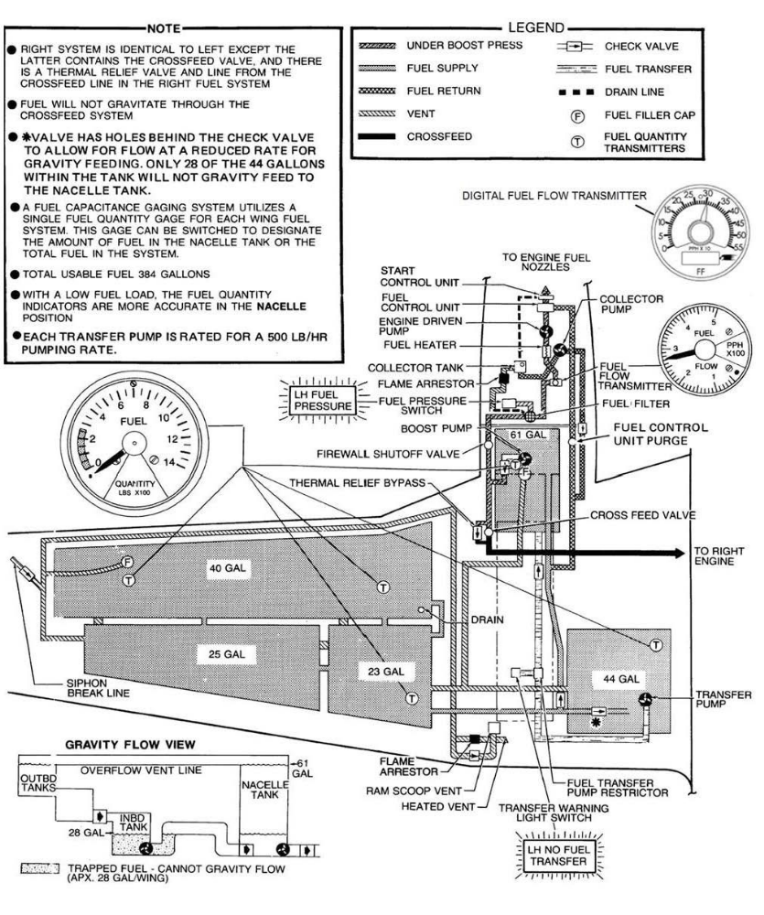

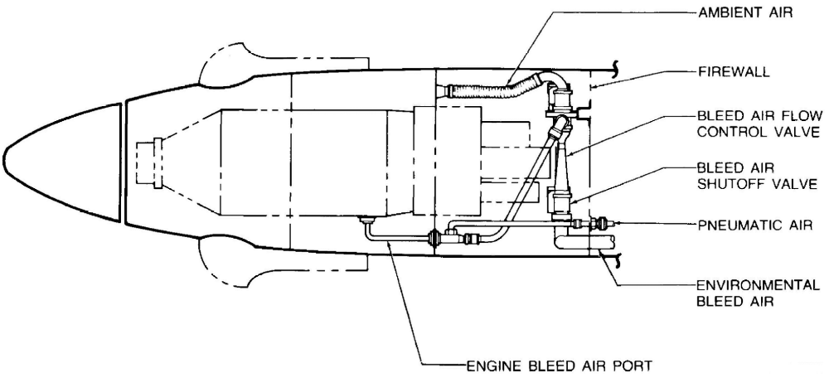

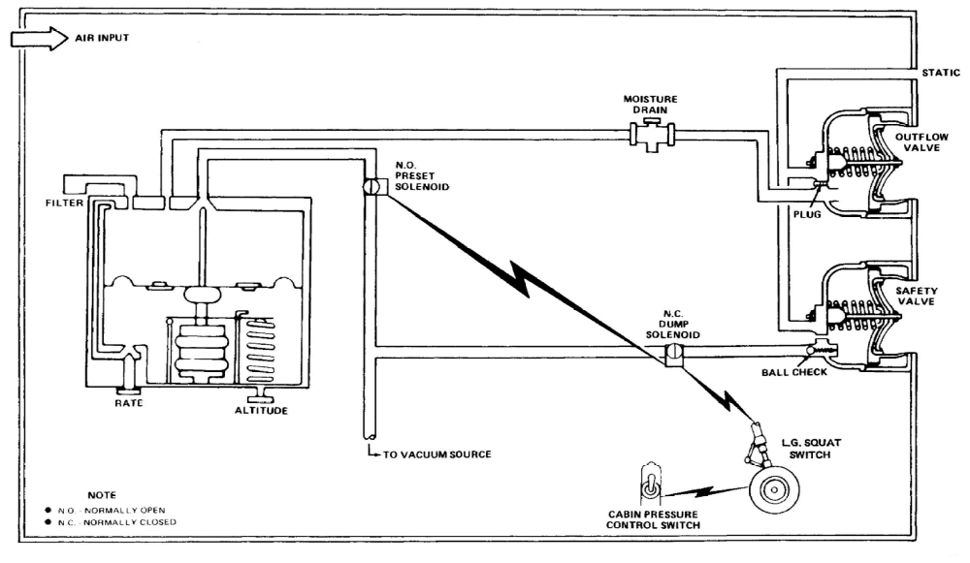

Brief/Debrief Notes

