C4101

DISCUSS ITEMS
Outside scan techniques, see and avoid, takeoff, crosswind takeoff and landing, aborted takeoff, landing pattern, full-stop landings, touch-and-go procedures, Training Time Out, NATOPS brief, dual engine waveoffs, aircraft engine operating limits, engine start procedures, abnormal starts/malfunctions, and brake system/malfunctions.

Outside Scan Techniques
- 10 degree blocks

See and Avoid
- VFR/IFR
- Proper Verbage
FTI – 2. See And Avoid
Operating on an instrument clearance still requires you to scan for other traffic. The only separation normally provided by Air Traffic Control (ATC) is between other Instrument Flight Rules (IFR) traffic. Even though other aircraft may be operating legally, never assume you are protected in any airspace.
Clearing procedures described in this section must be adhered to at all times. When making turns on the ground or in the air, clear your flight path left and right. The OBS is also very valuable in searching for traffic.
NOTE
Whenever reporting other aircraft, utilize the following terminology: “Traffic in sight” or “Negative contact.” Do not utilize “Talley ho” and other such phrases not found in the pilot/controller glossary. Utilize “Roger” to indicate reception of a transmission, not an “Affirmative” or “Negative” response. Utilize “WILCO” to indicate reception and compliance.
OPNAV – 5.2.3 See and Avoid
The see-and-avoid concept applies to visual flight conditions, thus eliminating the need for specific route clearance from ATC agencies under most circumstances. Since pilots are responsible for their own separation from other aircraft, conditions must exist that permit ample opportunity to see and avoid other air traffic and maintain obstruction clearance. The following measures shall serve as additional precautions when separation is maintained through the see-and-avoid concept, provided no degradation of the assigned mission will result.
a. Excepting single-seat aircraft, electronic equipment, such as airborne radar, should be used where feasible.
b. Where available, radar advisory service shall be requested especially when VFR flight is required through high-density traffic areas.

Takeoff
- Procedures

Crosswind takeoff & Landing
- Wing Low, Top Rudder
7.10.2 Crosswind Takeoff
In accomplishing a crosswind takeoff, directional control may be more difficult to maintain. Leading with upwind power at the beginning of the takeoff roll will assist in maintaining directional control. Keep the nosewheel on the surface and apply upwind aileron to maintain a wings-level attitude. Firmly pull the aircraft off when flying speed is reached. Make the pulloff positive to keep from side-skipping as weight is lifted from the shock struts. Initial drift correction is made by turning into the wind with a shallow bank to counteract drift, then roll the wings level. Continue to climb straight ahead maintaining drift correction. Refer to Figure 26-2.
7.17.3 Crosswind Landing
No unusual technique is required in a crosswind landing. Use the wing low method. Allow for drift while turning on final approach so that the approach leg will not be overshot. Establish drift correction as soon as drift is detected. Use ailerons and top rudder as necessary to counteract drift during flare and touchdown. Crosswind correction (ailerons) should be maintained during the ground roll.

Aborted Takeoff
- Dependent on Remaining Runway, Airspeed, Gross Weight, & Density
- Abort Procedure
- What to abort for (color of light)

Landing Pattern [Ref 2]
- Upwind
- Crosswind
- Downwind
- 180 (Abeam)
- 90
- Final

Full Stop Landings
- Any configuration
- Reverse & Brakes
- After Landing Checklist
- Props inadvertently at 1900
FTI – k. Full Stop
Dual-engine full-stop landings may be made in any flap configuration. Crosswind corrections must be maintained throughout the landing rollout. Once the nosewheel is on the runway, lift the power levers over the detent and smoothly pull into reverse. Use of reverse will depend upon circumstances. Prolonged full reversing with resultant airframe vibration, engine noise, and possible prop erosion should be avoided. Augment with smooth, even braking as required. Prop reverse is more effective at higher airspeeds and brakes more effective at lower airspeeds. Scan the length of the runway to maintain centerline. Come to a slow taxi prior to making any abrupt turns to avoid stressing the gear. The After Landing Checklist shall not be commenced until clear of the runway.
If a landing is made with props inadvertently left at 1900 RPM, slowly advance the props full forward prior to utilizing reverse, or stop using brakes only.

Touch-And-Go Procedures:
- Brief
- Malfunction during Touch & Go
- Landing Pattern
“Once safely on the runway, I’ll call ‘Reset Flaps, Trim’ and advance the power levers to 12 o'clock.
You reset flaps and trim; call ‘Go’ with engines spooled up; call ‘Rotate’ at VR with takeoff power set”
FTI – l. Touch and Go
If a malfunction occurs during the touch and go, consideration should be given to runway remaining prior to aborting. It is recommended with less than 2000 ft remaining (past the two thousand feet remaining marker or the “two board”) and power levers advanced beyond the 12 o’clock position that the takeoff be continued. Do not try to abort at this time. This recommendation does not replace pilot judgment during a catastrophic emergency. Immediate action must be taken to determine if the takeoff can be continued

Training Time Out

Natops Brief

Dual Engine Waveoff
- Min Alt for IP initiated
- Reasons to execute
- Side of runway and Alt
- Procedure
FTI – 3. Waveoff
Waveoffs shall be accomplished in accordance with NATOPS. Waveoffs allow safe transition from low-powered, descending flight, to high-powered, climbing flight. The maneuver is designed to stop altitude loss as soon as possible while transitioning to a climb at the desired climb speed. Minimum altitude for an IP initiated practice waveoff is 100 feet. The IP may take the controls and execute any waveoff required below 100 feet. A waveoff shall be executed under the following conditions:
a. Excessive overshoot of the runway/greater than 30º AOB required during the approach turn.
b. Landing clearance has not been received by short final.
c. The IP, wheels watch, Tower, or the RDO issues any verbal or visual waveoff signal.
d. Any time three green lights are not visible after rolling onto final.
e. Any time the PF feels an unsafe condition exists.
f. Give consideration to waving off if touchdown cannot be accomplished on the first one-third of the runway.
Be alert to reducing power and leveling at 500 feet, unless cleared downwind. Do not exceed pattern airspeeds or overtake other aircraft. Initiate the waveoff by adding power as required and establishing a positive rate of climb. Then, offset slightly from the runway (on the pattern side) to allow a better view of traffic over or on the runway. When you’re cleared for the option, you’re cleared for a touch and go, low approach, missed approach, stop-and-go, or a full stop landing. Common errors include beginning the offset too early or communicating with Tower before flying the airplane.

Aircraft Engine Operating Limits [Ref 3 (NATOPS Fig 4-2)]
- ITT
- Torque
- Turbine Tachometer (N1)
- Propeller Tachometer (N2)
- Oil Temp & Pressure

Engine Start Procedures

Abnormal Starts/Malfunction
- Hot, Hung, No
- Procedure
- Limits

Brake System/Malfunctions [Ref 1]
- Shuttle Valve
- Location of Reservoir
- Loss of Brakes
- Hot Brakes
2.14 WHEELBRAKE SYSTEM
The main landing wheels are equipped with hydraulic brakes actuated by master cylinders attached to each of the rudder pedals for both pilot and copilot brakes (Figure 2-15). A shuttle valve, adjacent to each set of pedals, permits braking action changeover from one set of pedals to the other. Brake fluid is supplied to the system from the reservoir in the nose compartment. The toe brake sections of the rudder pedals are connected to the master cylinders that actuate the system for the corresponding wheels. No emergency brake system is provided. Reverse or beta (zero thrust) should be used to taxi and to slow the aircraft after landing. The following precautions should be observed in so far as is practical. Immediately after landing or at any time when there is considerable lift on the wings, extreme care should be used during any braking application to prevent skidding the tires and causing flat spots. Proper traction cannot be expected until the tires are carrying the aircraft weight. In the event that maximum braking is required after touchdown, the propellers should be reversed immediately and the brakes applied smoothly and evenly to the end of the ground roll.
Loss of Brakes
1. Maintain direction control with rudder, nosewheel steering, or differential power.
2. BETA/REVERSE to decelerate
3. Maneuver to open area and stop
4. Do not taxi
5. Check shuttle brake valve (pull back on top of pedals)
13.3 LOSS OF BRAKES
In the event of wheelbrake failure, maintain directional control with rudder, nosewheel steering, or differential power or a combination of all three. Use propeller reversing or beta range as required to assist in deceleration. If possible, maneuver into an open area and allow the aircraft to stop. Do not attempt to taxi the aircraft. A brake shuttle valve sticks occasionally which results in a loss of brakes for either the pilot or copilot or both. After the aircraft is stopped, the shuttle valve can sometimes be reseated and brakes restored by pulling aft on the top of the brake pedals.

Hot Brakes
1. Stop with REVERSE and minimal braking
2. Request assistance
3. Cool brakes using propwash

13.4 HOT BRAKES
Hot brakes usually are caused by excessive or heavy braking action. If hot brakes are suspected, stop the aircraft utilizing reverse thrust and minimum braking, request assistance if necessary, and allow the brakes to cool utilizing propwash. Allow the brakes to cool and ensure the brakes are inspected prior to further operation.
WARNING
All crewmembers are to stay a safe distance away from the aircraft. It is preferable to stay well behind the aircraft. If a wheel explodes because of rapid cooling, the fragments tend to fly out sideways from the wheel. A tire may also explode from the heat of the fire. Do not attempt to fight the fire.
CAUTION
The high energy absorbing capacity of the wheelbrakes is capable of locking the wheels during maximum braking which may result in blown tires.

Brake Fire
Is criteria for EMERGENCY SHUTDOWN ON DECK.
Fire Extinguisher is not required.
Evacuate on non-fire side.
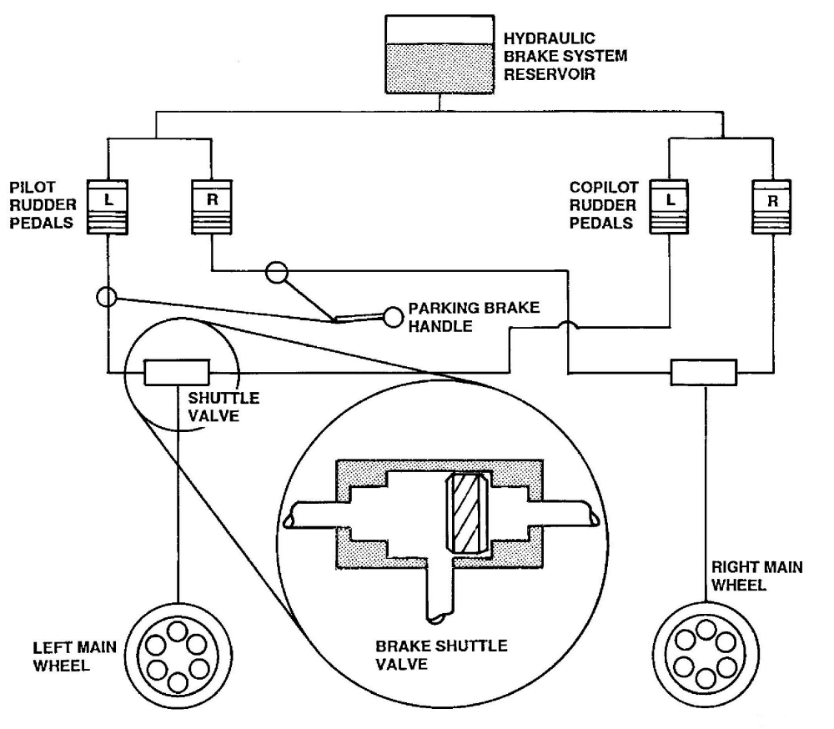

Brief/Debrief Notes

