C2101

DISCUSS ITEMS
Seat/rudder pedal adjustment, fuel management panel, pilot instrument panel, engine instruments and switches, center instrument panel, annunciator panel/analysis, right seat instrument panel, circuit breaker panels, control pedestal, overhead control panel, MFD, checklists: before start, engine start, after start, brake check, engine runup, takeoff, after landing, and secure.

Seat/Rudder Pedal Adjustment
2.12.2 Rudder Pedals
A two-position fore and aft adjustment of the pedals is provided through control levers on each pedal.
2.21.1 Seats
The pilot compartment seats are adjustable fore and aft with the inboard handle on each pilot seat and vertically with the outboard handle. The three passenger seats normally installed are adjustable fore and aft with adjustable headrests and seat backs that may be reclined for individual comfort.

Fuel Management Panel
2.9.3 Fuel Management Panel
This panel contains the switches for the firewall shutoff valves, boost pumps, fuel transfer pumps, fuel transfer test, a switch for the crossfeed system, fuel system circuit breakers, fuel quantity indicators, and the fuel quantity selector switch. 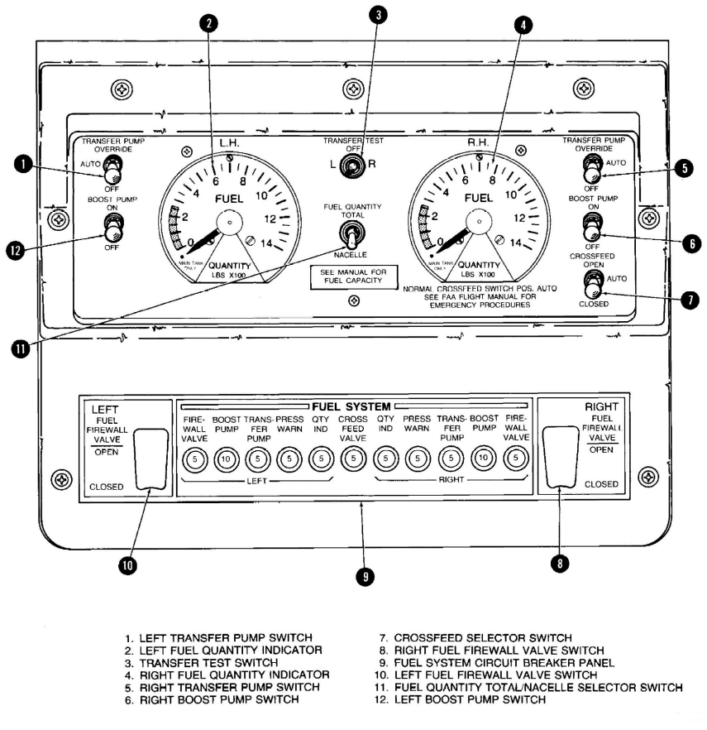
Pilot Instrument Panel // RS Instrument Panel
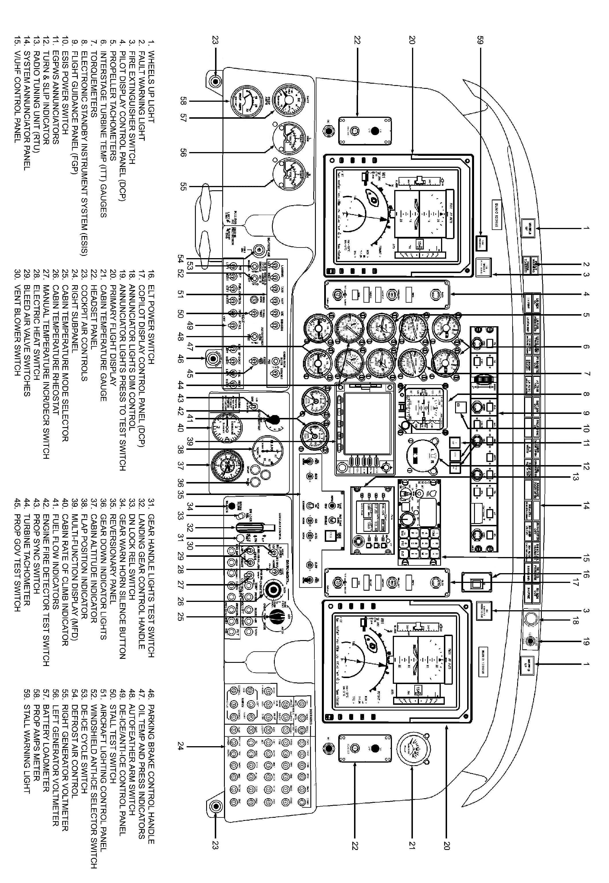
Engine Instruments and Switches
2.7.1 Interstage Turbine Temperature Indicators
The ITT gauges are calibrated in degrees Celsius. Each gauge is connected to a thermal sensing element that is located in the hot gases between the turbine wheels. The ITT gauges register the temperature present between the compressor turbine and power turbine for the corresponding engine. For aircraft with digital engine indicators (AFC-24), circuit protection for the digital readout is provided via the circuit breakers placarded ITT on the right sidewall circuit breaker panel.
2.7.2 Turbine Tachometers
The turbine tachometers register compressor turbine rpm (N1) for the respective engine. These indicators register as a percentage of maximum compressor turbine rpm. Each instrument is slaved to a tachometer generator attached to the respective engine mounted on the lower accessory section. For aircraft with digital engine indicators (AFC-24), circuit protection for the digital readout is provided via the circuit breakers placarded Ng TACH on the right sidewall circuit breaker panel.
2.7.3 Engine Torquemeters
Each engine torquemeter indicates torque applied to the propeller shaft of the corresponding engine. The torque applied to the propeller shaft generates an equal and opposite reaction on a movable ring gear located in the first reduction gear stage. Movement of the ring gear operates a variable oil metering orifice, metering engine oil pressure across the orifice to a calibrated pressure transmitter in proportion to the torque sensed. The torque transmitter sends a 26-volt alternating current signal to the engine torque gauges that show torque in 100 foot-pound increments. For aircraft with digital engine indicators (AFC-24), the ac transmitter has been replaced and is now dc. The torquemeter circuits are protected by their respective circuit breaker, placarded torquemeter left and right, located on the right sidewall circuit breaker panel.
2.7.4 Propeller Tachometers
The propeller tachometers register propeller speed in hundreds of rpm. Each indicator is slaved to a tachometer generator unit attached to the corresponding engine mounted on the reduction gear case 1-o'clock position. For aircraft with digital engine indicators (AFC-24), circuit protection for the digital readout is provided via the circuit breakers placarded Np TACH on the right sidewall circuit breaker panel.
2.7.5 Fuel Flow Indicators
The fuel flow gauges register the rate of flow for consumed fuel via the fuel flow transmitters that are located between the fuel filter and oil to fuel heater in the fuel lines of the respective engines (Figure 2-5). Flow indicators receive electrical dc power from the No. 1 and No. 2 dc subpanel buses and are calibrated to show the flow of fuel in increments of hundreds of pounds per hour. Digital indicator displays provide greater resolution. Circuit protection is provided via the circuit breakers placarded FUEL FLOW and located on the right sidewall circuit breaker panel.
2.7.6 Oil Pressure and Oil Temperature Indicator
The combination oil pressure and oil temperature indicators are electrically powered by the No. 1 and No. 2 subpanel dc buses and indicate oil pressure in psi and oil temperature in degrees Celsius at the delivery side of the oil pump for each engine (Figure 2-2). Circuit protection of the oil temperature and pressure indication system is provided via the circuit breakers placarded OIL TEMP & PRESS and located on the right sidewall circuit breaker panel.

Annunciator Panel/Analysis
Review NATOPS Figure 12-1. Caution/Annunciator Lights for conditions and actions associated with each light.
2.16.1 Annunciator Panel
The annunciator panel (Figure 12-1) mounted across the top of the instrument panel glareshield provides a visual monitor for critical functions of the aircraft and indicates conditions for which appropriate corrective action must be taken. The panel presents two rows of small rectangular windows that illuminate as either yellow, red, or green. Also included with this group, but located on the center instrument panel, are three caution/warning lights associated with the TAWS.
2.16.1.1 Dimming Control
The intensity of all lights on the annunciator panel are dimmed by a common DIM control. When yellow or green indicator lights illuminate, they will be at the intensity as set by the DIM control. Whenever a fault indicator (red light) is illuminated, all illuminated annunciator lights will be at maximum brightness. When the FAULTWARNING light is reset, all lights will dim to the level set by the DIM control. Dimming cannot be accomplished until after reset. The yellow TERRAIN N/A annunciator located on the center instrument panel is dimmable, but the red PULL UP and yellow TERRAIN annunciators are not. The annunciator light system is powered by the No. 1 subpanel bus and is protected by a circuit breaker placarded ANN LIGHTS and located in the INDICATOR section of the copilot outboard subpanel.
Control Pedestal
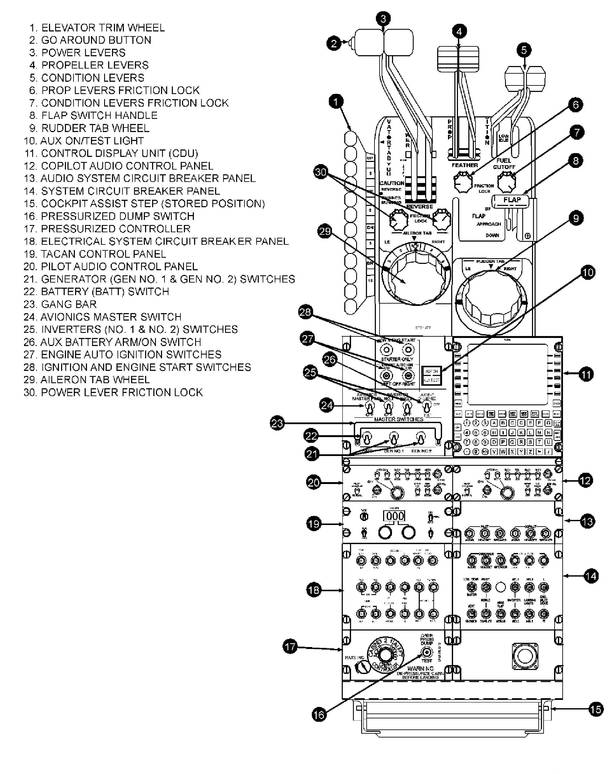
Overhead Control Panel
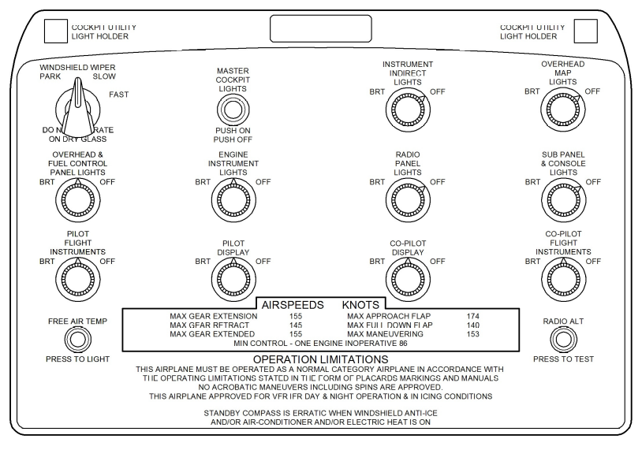
Before Start Checklist – Accomplish the Before Start Checklist in accordance with NATOPS and Appendix F of the FTI.

Engine Start Checklist – Start engines in accordance with NATOPS and Appendix F of the FTI.
If starting during darkness, the PM should use a flashlight to provide extra illumination of the gauges (especially ITT). Panel lights may dim significantly when the starter is energized. NOTE: Should an APU start be required, see Section III of NATOPS.

After Start Checklist – Accomplish the After Start Checklist in accordance with NATOPS and Appendix F of the FTI.
Brake check – In order to free the lineman, hold the checklist at Step 4 (AUX Bat/Avionics Master—ON). Brief the PM, then signal “brake check” to the lineman. When signaled to move forward, report “Clear left;” RS responds “Clear right;” taxi slowly forward as directed for a brake check. After the aircraft stops and lineman dismissed, set the parking brake and direct PM to continue checklist.
Brief:
“Hold the Checklist. Keep the right side clear during all ground operations. Report ‘Out of the Chocks’ to Base on VHF once avionics master is on.”

Engine Runup Checklist – Accomplish the Engine Runup Checklist in accordance with NATOPS and Appendix F of the FTI.
Taxi into the runup area and stop with approximately 15’ wingtip distance between the next aircraft and yours. Ensure the nosewheel is not cocked and is aligned with runway heading.
NOTE: The propeller of the outboard engine shall not cross the runway edge marking of RWY 4/22 while maneuvering the runup area. Doing so could result in a propeller striking a runway edge light.

Takeoff Checklist – Accomplish the Takeoff Checklist in accordance with NATOPS and Appendices B/F of the FTI.
Brief:
“Back me up on the power quadrant and monitor the engine and flight instruments.
Call out any malfunctions. All malfunctions will be handled in accordance with NATOPS.
Call rotate at 91 knots and note the time of takeoff.
This will be a course rules departure to _______.
For an emergency after takeoff requiring an immediate return to the airport, we will maintain VFR and request a downwind for runway ___.”
NOTES: (1) Block assignments/instrument departure requests shall be made from the runup area on all FAM/BI/FORM flights. If takeoff is not commenced within 30 minutes, cancel your block reservation with Seagull so the airspace may be utilized by other aircraft. (2) If a return to the field in VMC conditions is not possible, ensure an approach above minimums is available in the local area, and IAPs are readily accessible.

After Landing Checklist – The After Landing Checklist must be completed after each full stop landing (unless taxiing back on the active runway for immediate takeoff). PF shall not set Condition Levers to Low Idle until clear of the active runway and stopped. It is advisable to contact ground for taxi after clearing the active runway; then call for the checklist during taxi. Ensure the PF delegates appropriate checklist items to PM in order to allow full concentration on taxiing the aircraft safely.

Secure Checklist – Unless cockpit duties preclude it, PF calls “First six items of the Secure Checklist” upon completion of the After Landing Checklist. The checklist may be held as required to request parking spot or to report arrival.
Brief/Debrief Notes

